y



**SM6P07NI Digital Media Project**

**20% Report**

**2019-20 Autumn**

**Student Name: Rahul Balami**

**London Met ID: 22067315**

**College ID:** NP01MM4A220025

**External Supervisor:** Enter your External Supervisor Name Here

**Internal Supervisor** Enter your Internal Supervisor Name Here

**Assignment Due Date: Wednesday, May 7, 2025**

**Assignment Submission Date:** Click or tap to enter a date.

**Word Count: 3652**

*I confirm that I understand my coursework needs to be submitted online via Google Classroom under the relevant module page before the deadline in order for my assignment to be accepted and marked. I am fully aware that late submissions will be treated as non-submission and a marks of zero will be awarded.*

Abstract

PurrKour is a 2D pixel-art platformer game development project, inspired by parkour, it implements game mechanics and a charming visual storytelling elements. Developed in GDevelop (game logic and mechanics) and Aseprite (character and environment design), PurrKour seeks to explore how movement systems, where moving is fluid (with parkour dynamics), fit into a richly developed urban area based on design dimensions. The players complete levels that feature obstacles that must be navigated, enemy dogs must be dodged and killed, and levels must be completed in an older (peaceful) pixel-art neighbourhood.

This documentation outlines the entire production process, from pre-production planning to production phases (characters, animations, UI, etc.), and post-production processes (compiling, testing, polishing, etc.). The primary goal of the project was to explore how intuitive mechanics, coupled with nice aesthetics that emphasize visual storytelling in a pixel-art style game could enhance player buy-in and story engagement. This report also covers research inherent in the visual style, game mechanics, game development tools as well as a step-by-step discussion of the creative and technical pipeline.

Table of Contents

Table of Figure 5

1. Introduction 1

1.1. PurrKour 2

1.2. Area of Research 3

1.2.1. Game Development Tools and Methods: GDevelop and Aseprite 3

1.2.2. Genre and Visual Style: Narrative Platformers and Pixel-Art Environments 4

2. Aims of Project 6

3. Target Audience 7

4. Product Research 8

4.1. Game Development 8

4.2. Health Bar 9

4.3. Patrolling Enemy 10

4.4. Creating a platformer game 11

5. Technologies Employed 13

5.1. G-develop: 13

5.2. Aseprite 13

5.3. Youtube 13

6. Project Plan 14

6.1. Previous Plan 14

6.1.1. Pre-Production Gantt Chart 14

6.1.2. Production *Gantt Chart* 14

6.1.3. Post-Production Gantt Chart 15

6.2. Current Plan 16

6.2.1. Pre-Production Gantt Chart 16

*6.2.2.* Production *Gantt Chart* 16

*6.2.3.* Post-Production *Gantt Chart* 16

6.3. Pre-production Phase 17

Character Design 17

Colour theory 17

Mood Board 17

Environment Design 17

6.4. Production Phase 18

Character Development 18

Animation 18

Enemy AI 18

User Interface 18

Sound Effect 18

6.5. Character Design 19

6.5.1. Dog Character 19

6.5.2. Main cat character (Front and side view) 21

6.5.3. Cat hurt 23

6.5.4. Enemy character 24

6.5.5. Footpath 25

6.5.6. Settings Button 27

6.6. Post-Production 28

7. Resources and testing tools 29

7.1. Hardware Tools 29

7.1.1. XP-Pen Deco Pro 29

7.1.2. Lenovo Legion 5 30

7.2. Software Tools 31

7.2.1. G-develop: 31

7.2.2. Aseprite 32

7.3. Websites used 33

7.3.1. Pinterest 33

7.3.2. YouTube 33

7.3.3. Google Form 33

8. User Testing & Findings 34

Survey 34

Reflection on the survey result 35

9. Conclusion 37

10. References 38

11. Bibliography 39

12. Appendix 40

12.1. Mail exchange with client 40

12.2. DMP Letter provided by college 41

12.3. Weekly Logs 42

# Table of Figure

Figure 1: Celeste game 4

Figure 2: Stray 5

Figure 3: Research on game development 8

Figure 4: Research on implementation of health bar 9

Figure 5: Research on implementation of patrolling enemy 10

Figure 6: Research on implementation of platformer game 11

Figure 7: Implementation of platformer game without coding 12

Figure 8: Pre-production gantt chart 14

Figure 9:Production gantt chart 14

Figure 10:Post-Production gantt chart 15

Figure 11: Pre-production gantt chart 16

Figure 12: : Production gantt chart 16

Figure 13: Post-production gantt chart 16

Figure 14: Process of enemy design 20

Figure 15: Process of cat design 22

Figure 16: Process of hurt cat design 23

Figure 17: Process of enemy character design 24

Figure 18: Process of footpath design 26

Figure 19: Process of setting button design 27

Figure 20: XP-Pen deco pro 29

Figure 21: Lenovo Legion 5 30

Figure 22: G-develop application 31

Figure 23: Aseprite 32

Figure 24: Google form 33

Figure 25: Survey 34

Figure 26: Mail exchange with client 40

Figure 27: DMP Letter provided by college 41

# Introduction

This course allows students to understand and develop a 2D game project using standard tool for implementation and creative story-telling. On this development, it is crucial to understand the target audience preferences on gameplay, visual style, and narrative. As well as research similar, successful games and look into general game design principles to start building a foundation. Drawing the pre-production assets, such as character sketches, environment concepts and story outline into the planning process shapes the direction of the game as well as a coherent tone and structure. With tools like GDevelop and Aseprite were indeed instrumental during the creation process which employed game logic development as well as pixel art design.

From that point, the production phase focused on developing gameplay mechanics, including level design, and the implementation of narrative progression. There is, however, more emphasis on user engagement through storytelling and interactivity elements for sustaining player interest. A lot of the technical problems surfaced during production, and practical solutions were applied which enhanced the user experience. It has included creative problem-solving and applications of multimedia skills in a real-world setting. Self-evaluation and feedback were also integral in pinpointing strengths and areas for improvement, thus making this project a personal growth experience, in addition to being a technical one. Planning, creativity, and adaptability were thus promoted by the coursework overall.

## PurrKour

PurrKour is a 2D story-driven platformer game about a cat protagonist created in GDevelop for game development and Aseprite for pixel art making. The tale expresses the emotional travel of the main character, who was adopted into a peaceful urban household after being separated from its siblings, while the rejected siblings were left behind to survive on the streets. As time goes on, one of those street cats rises to power, becoming a leader of a gang of dogs looking later to exact revenge over the adopted sibling. The adopted sibling, consumed by betrayal and abandonment, sends this gang to attack the main character. This marks the beginning of events that prove to be an emotional and mechanical challenge for the player.

The game is set in a cozy buts slightly rundown pixel-art representation of the protagonist's hometown. The detail-rich backgrounds have rows of small shops, residential buildings, balconies, striped awnings, and realistic touches like air conditioning units and aging brick walls. The calm sky and the ambient hustle and bustle of the city create a dramatic juxtaposition to the conflict at hand, thereby lending a couple more layers to the experience of play. With inspiration drawn from deeply narrative games like Stray and Celeste, PurrKour seeks to engage the player with meaningful storytelling and smooth platforming mechanics, further driving the narrative emotional impact and game experience.

## Area of Research

There were two areas of research that were vital to the development of PurrKour, a 2D pixel-art story-driven platformer. This research development informed by the following guiding question:

“How can the use of particular tools, tropes, and aesthetics facilitate the development of an emotionally engaging, technically sound 2D platformer?”

The two primary areas that were engaged with in this project were:

### Game Development Tools and Methods: GDevelop and Aseprite

The first area of research was to identify the features, routine uses, and interoperability between GDevelop and Aseprite. GDevelop was selected for its no-code visual programming platform, alongside built-in support for sprite animation, character logic/behaviour, platforming physics, level design constructs, and UI components. The research explored how with event-driven logic, GDevelop could achieve complex relationships and narrative progression. Conversely, Aseprite was investigated for its role as a clean and expressive pixel-art animation tool and sprite-sheet creator.

Compatibility and workflow of these two tools were examined to ensure ease of asset integration and development. The findings proved that the tools met the project's artistic and mechanical outcomes and the acceleration of development and iteration for developing a game solo or in a small team was beneficial for an indie project.

* + 1. Genre and Visual Style: Narrative Platformers and Pixel-Art Environments

The second area of inquiry concerned visual storytelling, emotional tone, and specific genre mechanics. It was important to find the pixel-art style related to urban environments, atmospheric storytelling, and player feedback. Inspirations were sourced from classic to modern indie games to reach answers around the parkour-style movement, pacing level, and overall feel of the game.

Two big titles impacted the direction of the development of PurrKour in an important way:

* Celeste : considered the mechanics of movement, precision/platforming, and how it evokes emotional themes through its gameplay.

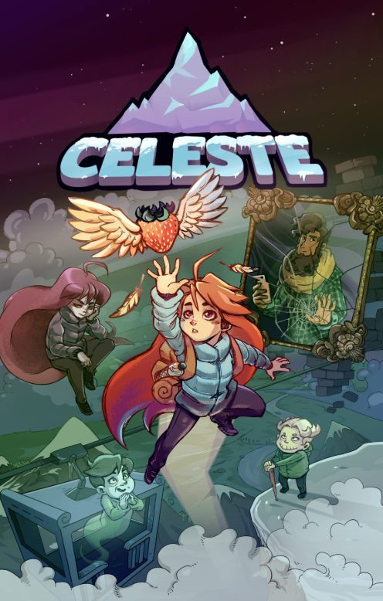

Figure 1: Celeste game

* Stray : referenced the narrative of a narrative of a lone cat wandering its urban world, but also how it employs environmental storytelling and tone.

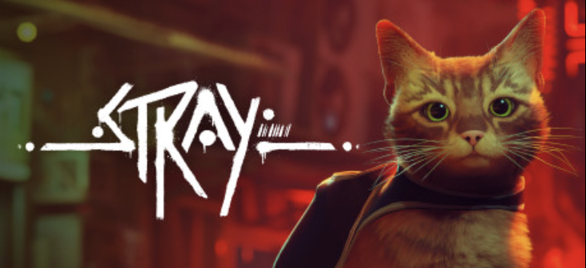

Figure 2: Stray

These references aided us in determining the mood and mechanical behavior of PurrKour. We could ensure the narrative and game were seamlessly working together to create a meaningful and emotional experience. Themes about abandonment, perseverance, and facing things head on were referenced through game logic and game visuals, intentionally designed by genre convention.

# Aims of Project

The aim of this project is to develop an emotional and artistically inspired 2D platformer game about storytelling, unique to independent video games. Using GDevelop and Aseprite, we want to create a game that is not only fun to play, but is also an amazing narrative experience. It will explore themes of family, abandonment and perseverance.

PurrKour is meant to inspire those individuals interested in being game developers and/or storytellers by showcasing the fact that interesting and meaningful games can be created with basic tools and little resources. It will act as a creative outlet that combines game play and narrative in a pixel-art world, while hopefully inspiring exploration and skillful movement through gameplay based parkour mechanics.

This project will provide meaningful examples of how smaller, indie productions can still provide meaningful user experiences. It will be directed towards players who appreciate a heartfelt story and a saturated immersive world, but also to be an excellent resource for students interested in video game courses, students studying character design, visual storytelling and independent game design development.

In the end, PurrKour was meant to highlight the possibility of creativity and self determination in developing video games and to encourage others to tell their own stories, through interactive media.

*.*

# Target Audience

PurrKour targets players primarily aged 21-25 of all genders and ethnicities, but specifically focuses on a demographic of urban and suburban players who are privy to and interested in finding and playing indie games. This group of players is often made up of students, young professionals, creatives, consumers of emotional or narrative media, or both. The players in this area will likely stitch the visual pixel-perfect design with the minimalist movement-based storytelling style of PurrKour. As a value proposition based partially on popular independent titles like Celeste and Stray, PurrKour uses parkour-style mechanics and movement for emotional expression and thematic behaviours about abandonment, trust, survival, and growth.

In consideration of the typical age of this audience, in the age group deemed Generation Z and Millennials specifically, players at this age group are predisposed to the inherent visual nostalgia of 2D side scrolled game art, but want depth through immersive and emotional narratives and gameplay. In way of performance, PurrKour features movement mechanics that are intent on agility and instinct and non-hierarchical objectives that may satisfy casual players and players requiring skill and accomplishment beyond single playthroughs. The story contains a stray cat as a central character in a decaying urban world, which may appeal to players who relate to the themes of isolation, resilience, and discovering our identity in the circumstances and location presented to them.

Due to its themes, emotional subject matter, and execution, we hope that it will not only nurture love among indie game lovers, but also students of game design or new creators wanting to embrace pixel art and narrative design in 2D platformers.

# Product Research

## Game Development

To create a game in Gdevelop which is a no-code, open-source and an easy game engine, the following tutorial was followed.

YouTube Link: <https://youtu.be/mckuSpr8vio?si=L0Ye98EbCzqhHbqp>

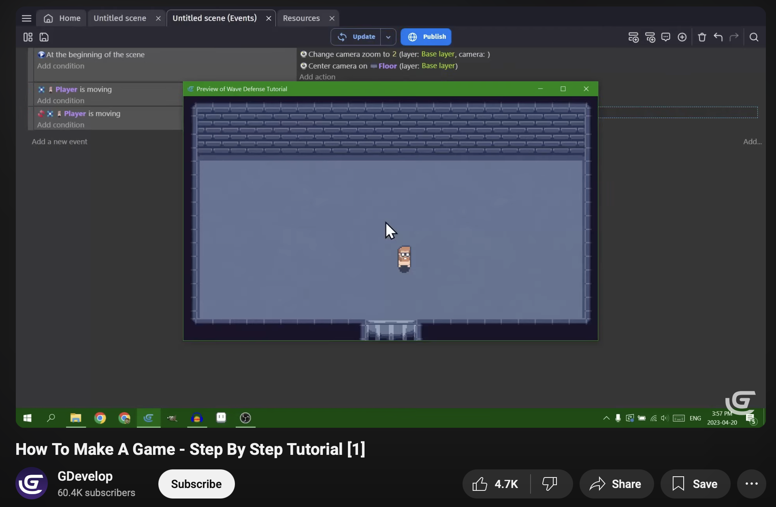

Figure 3: Research on game development

(GDevelop, GDevelop, 2025)

## Health Bar

To create a health bar on enemies to execute them by the protagonist, the following tutorial was followed.

YouTube Link: <https://youtu.be/HagU5uA0vxM?si=NlvpQ0QOUT0Dht_E>

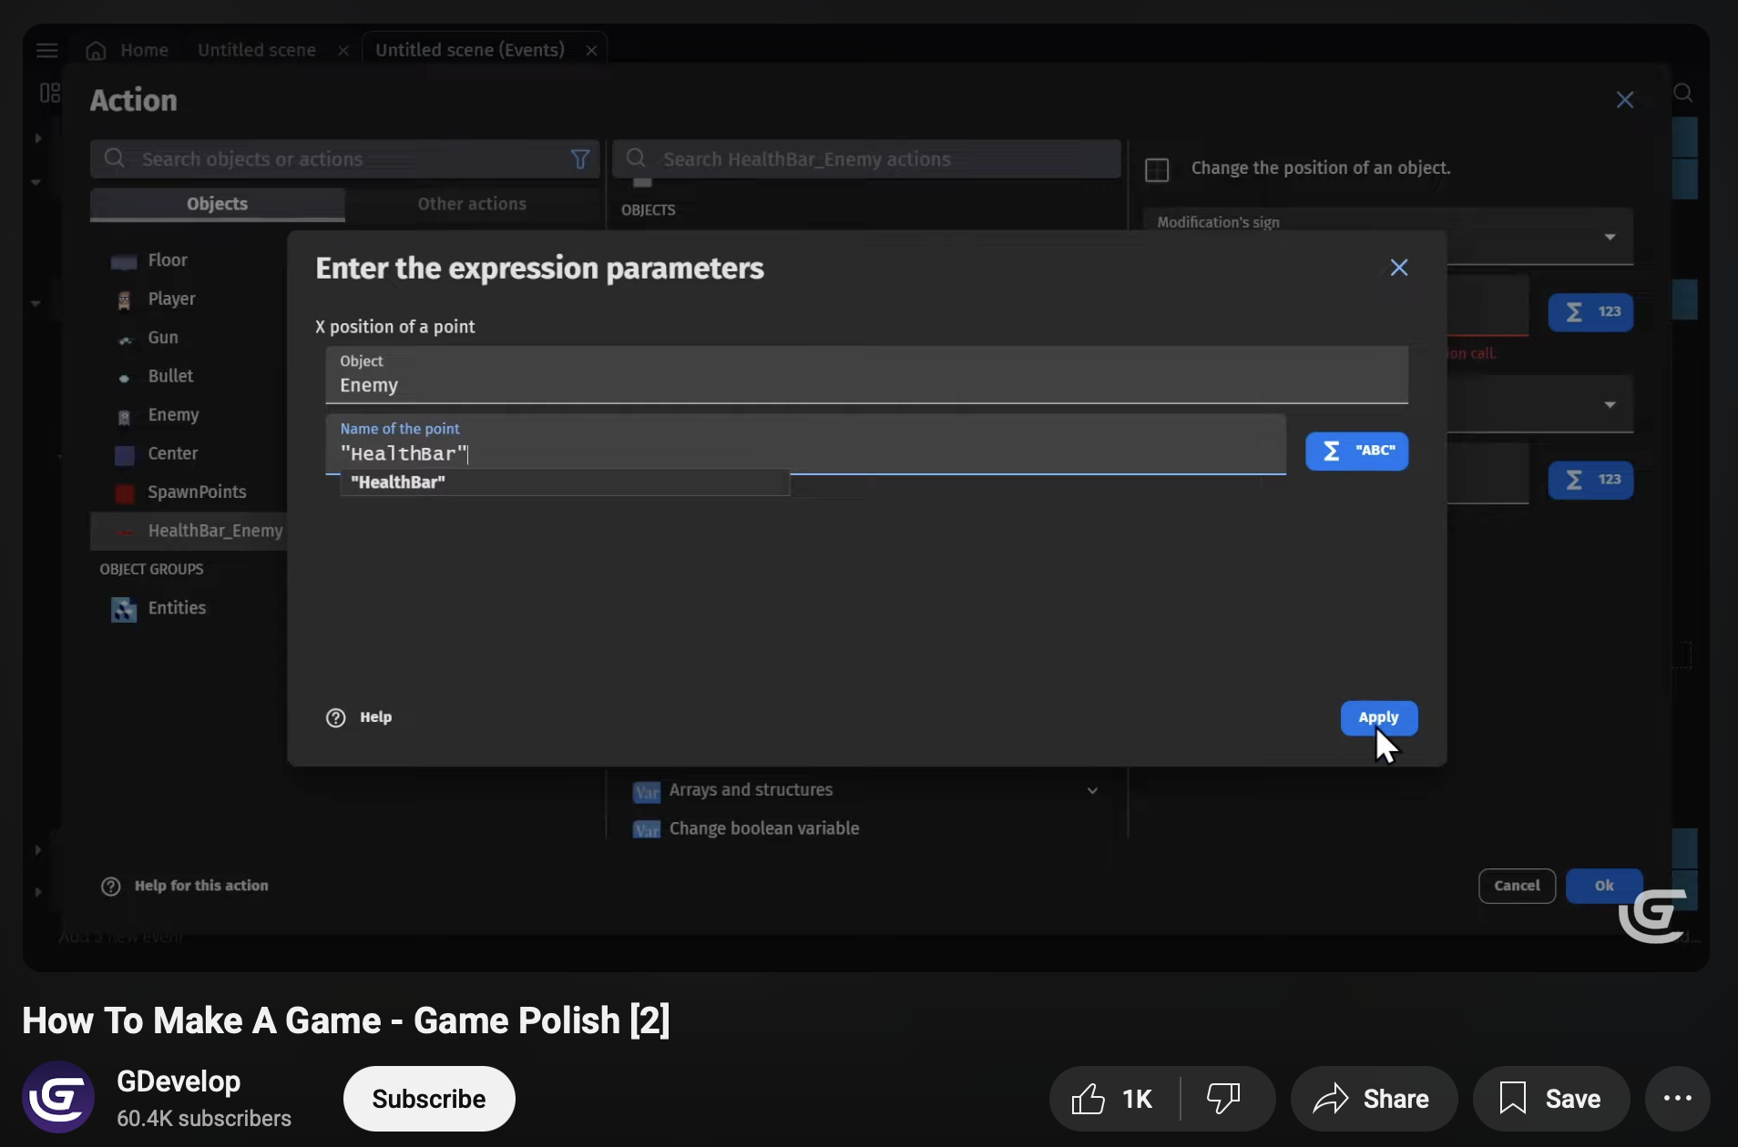

Figure 4: Research on implementation of health bar

(GDevelop, GDevelop, 2025)

## Patrolling Enemy

To create a multiple platformer behaviour enemy to attack on the protagonist, the following tutorial was followed.

YouTube Link: <https://youtu.be/0aGBYsrGwm0?si=euO3_D6MH4gUOLqR>

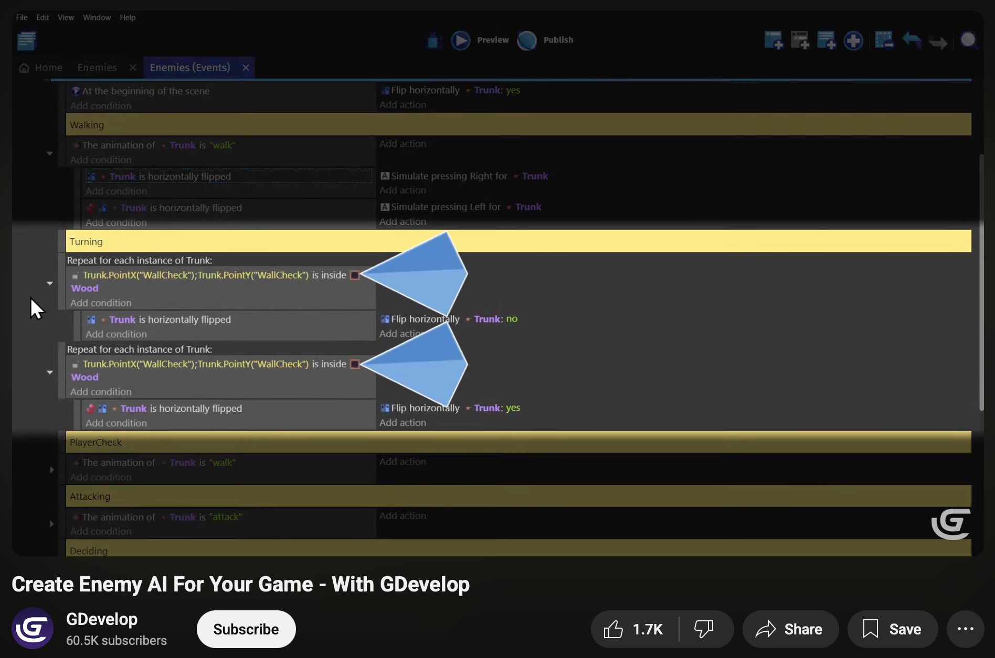

Figure 5: Research on implementation of patrolling enemy

(GDevelop, GDevelop, 2025)

## Creating a platformer game

The various movements such as jumping and move left and right for both the enemy and protagonist without coding were created following the tutorial below.

YouTube Link: <https://youtu.be/Li4vhL1bXLc?si=G7XtHTD9TUbop4vF>

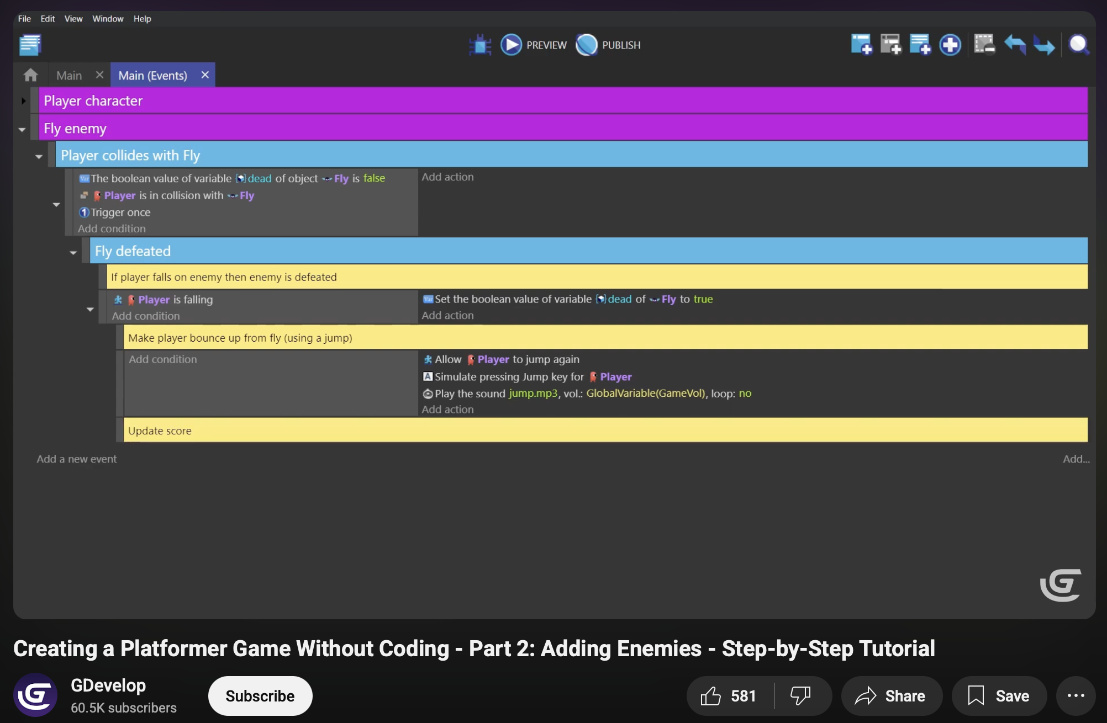

Figure 6: Research on implementation of platformer game

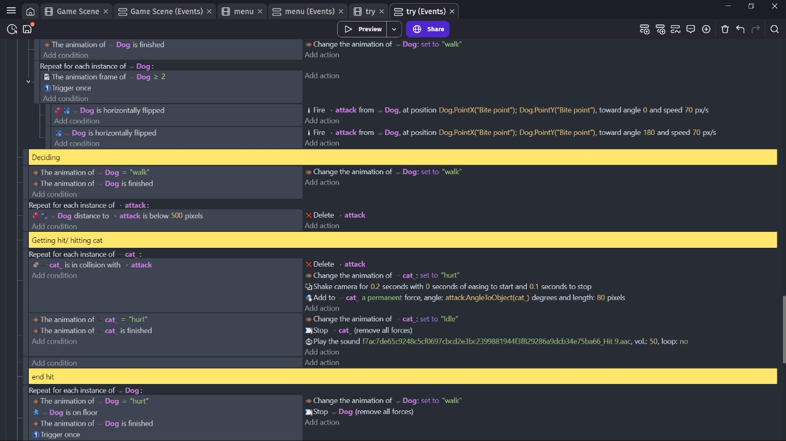

Figure 7: Implementation of platformer game without coding

(GDevelop, GDevelop, 2025)

# Technologies Employed

### G-develop:

* An open-source game development platform used for developing 2D game.

### Aseprite

* A pixel art tool used to design/animate the game; 2D settings and characters.
  1. Youtube
* A online platform used for research purpose on how to create.

# Project Plan

The revised project schedule indicates that delays to the project were primarily due to the additional time needed for pixel-art asset creation, animation and sound implementation. Extra animations and level specific design changes were added during phase two of the coursework to improve quality gameplay, that were also not considered in the project schedule prior. This meant that extra time spent on these processes resulted in delays for other scheduled processes, as reflected in the revised Gantt charts.

## Previous Plan

### Pre-Production Gantt Chart

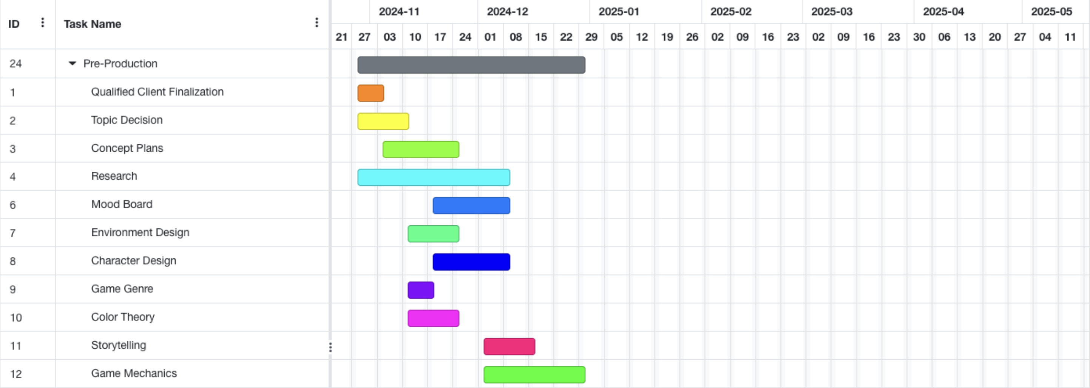

Figure 8: Pre-production gantt chart

### Production *Gantt Chart*

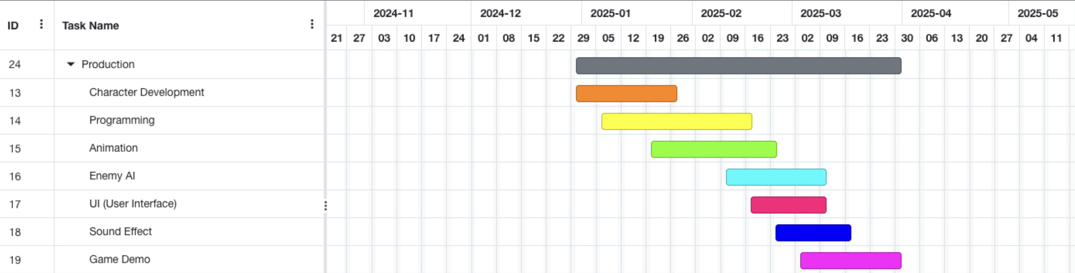

Figure 9:Production gantt chart

### Post-Production Gantt Chart

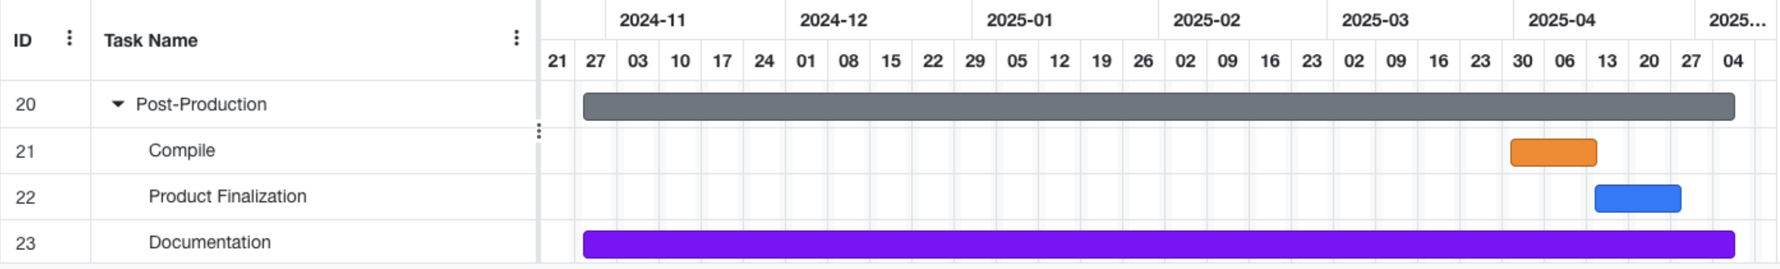

Figure 10:Post-Production gantt chart

## Current Plan

### Pre-Production Gantt Chart

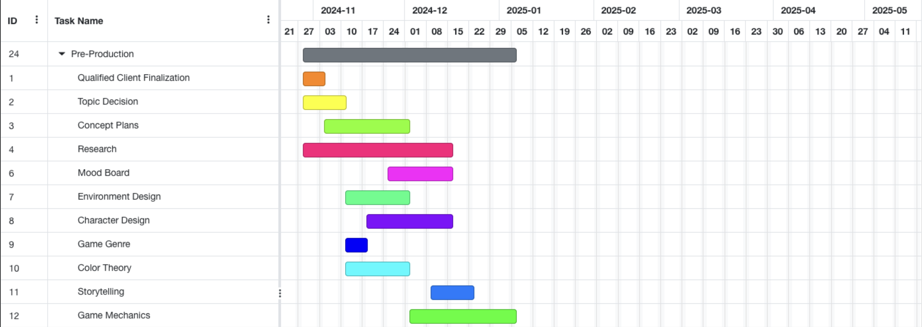

Figure 11: Pre-production gantt chart

### Production *Gantt Chart*

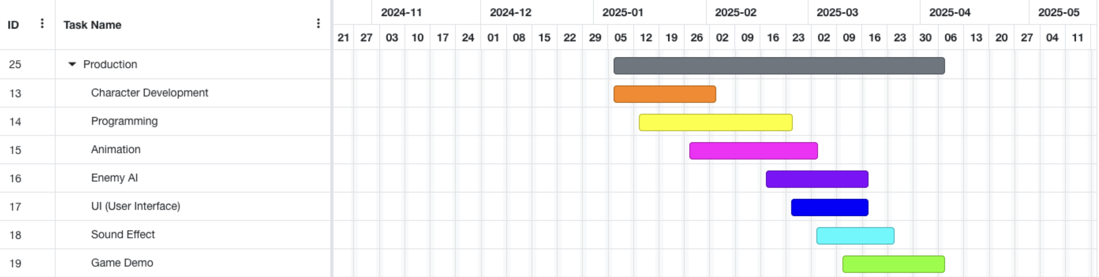

Figure 12: : Production gantt chart

### Post-Production *Gantt Chart*

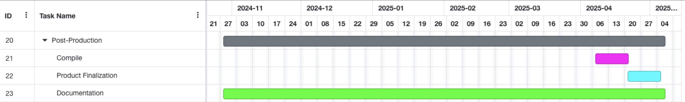

Figure 13: Post-production gantt chart

## Pre-production Phase

### Character Design

### Colour theory

### Mood Board

### Environment Design

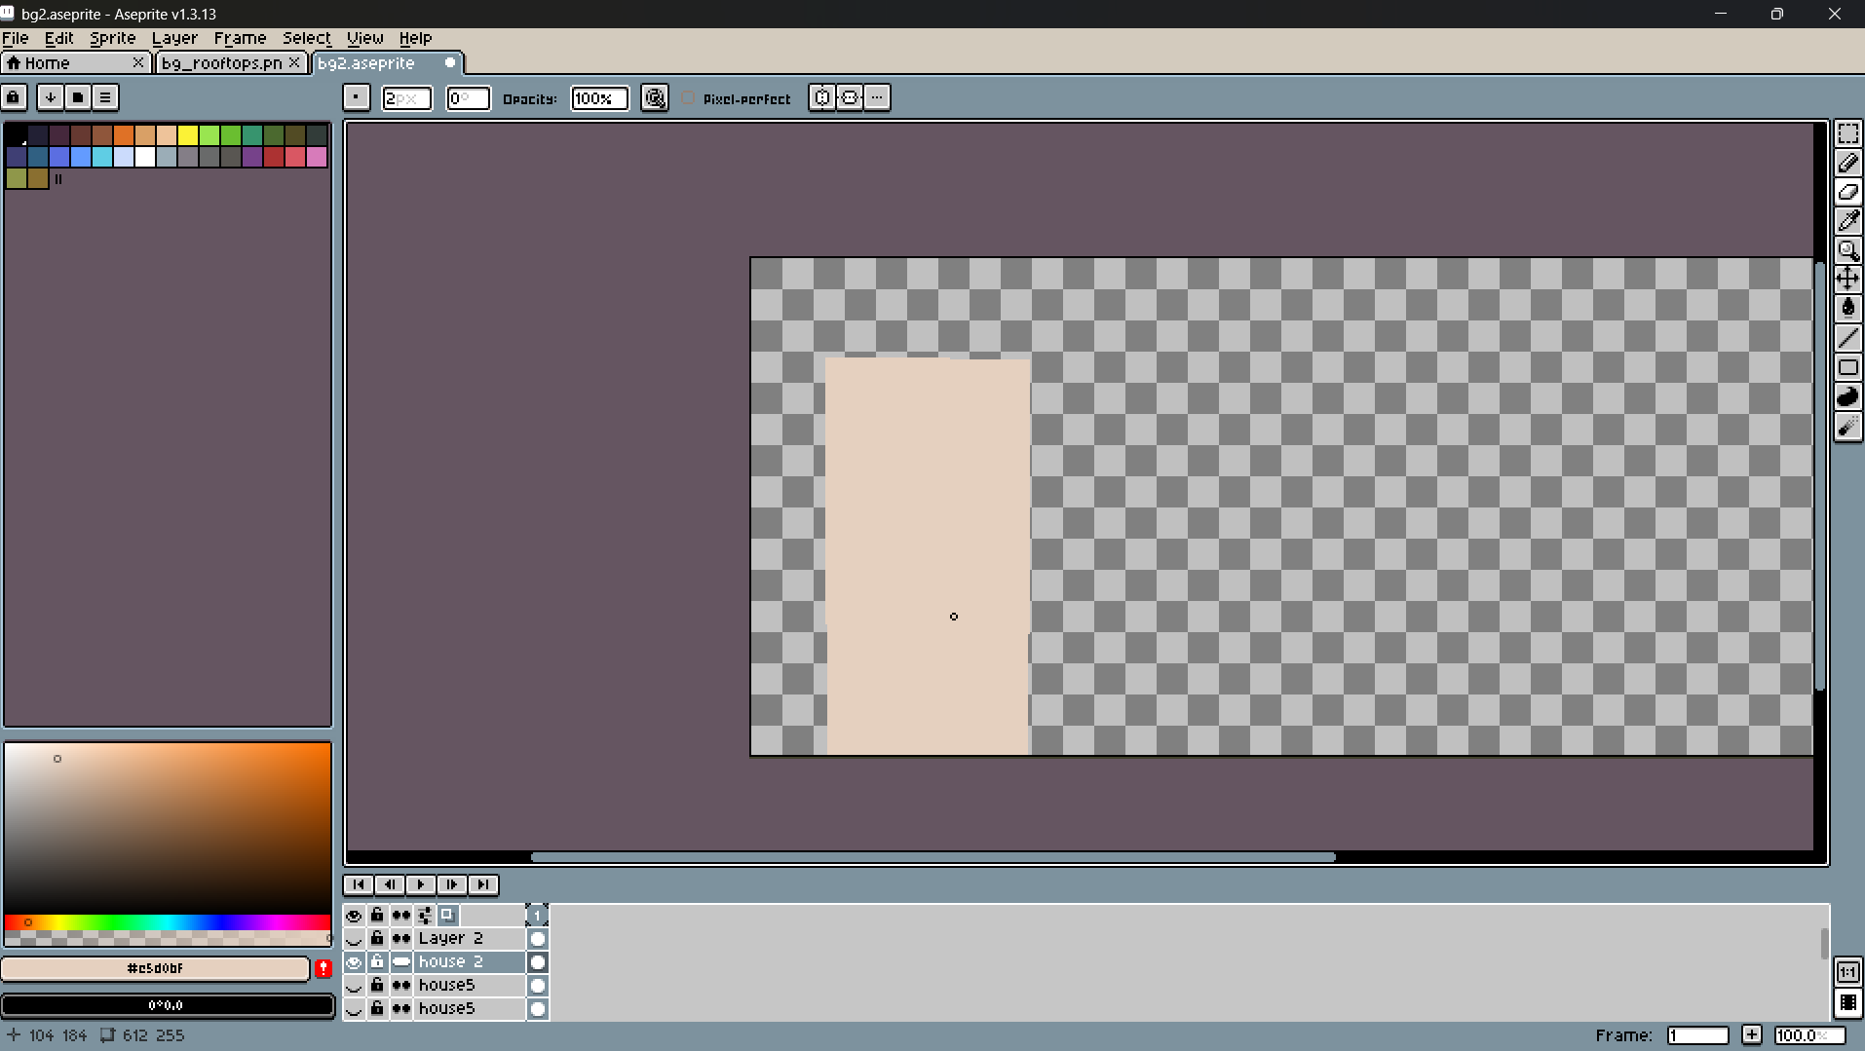

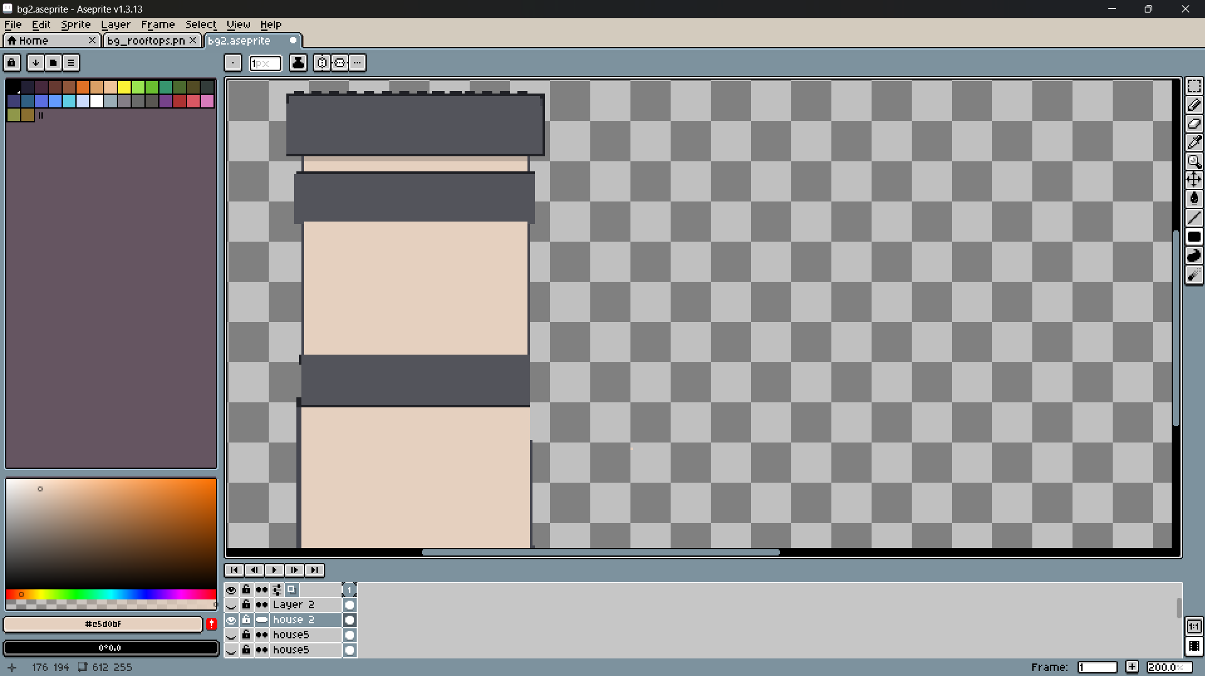

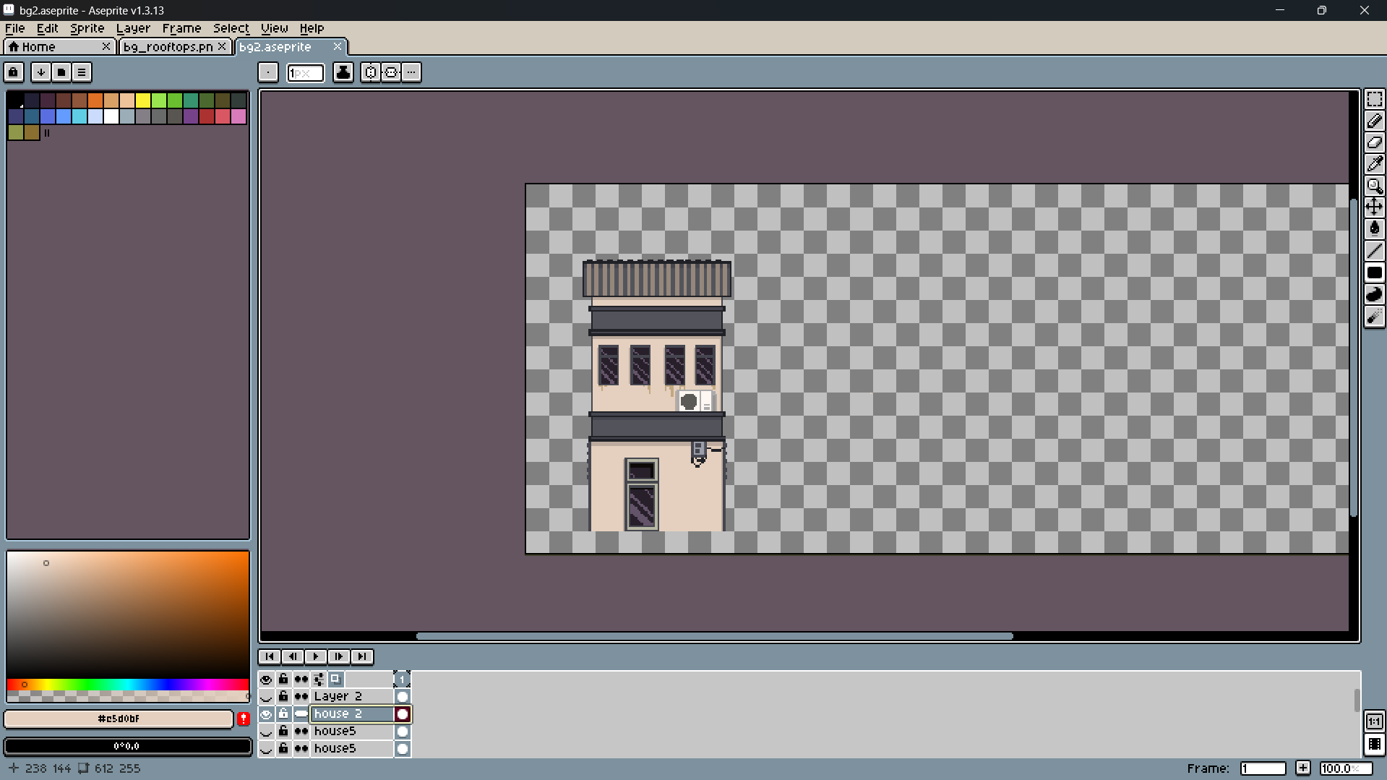

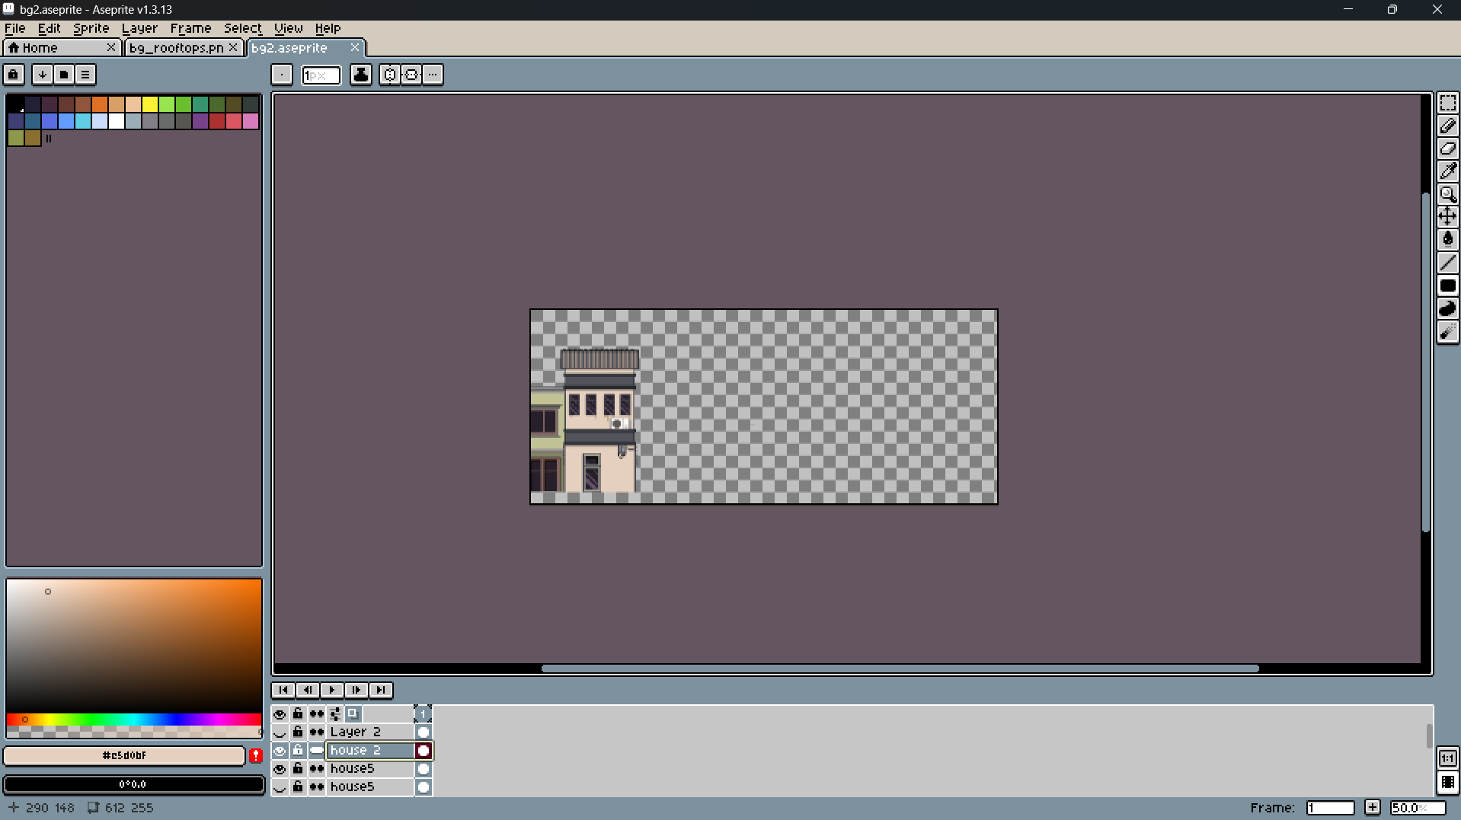

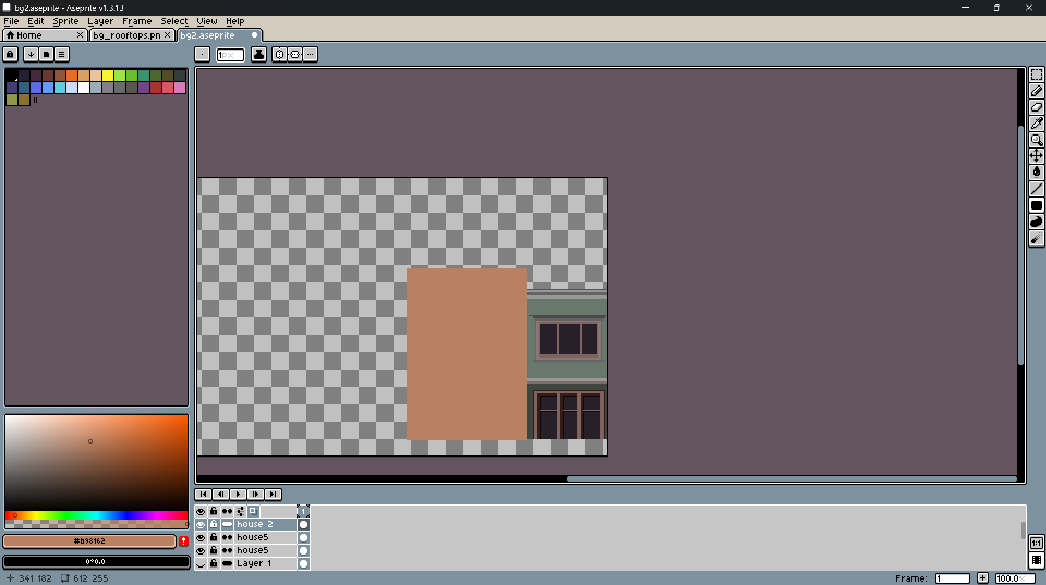

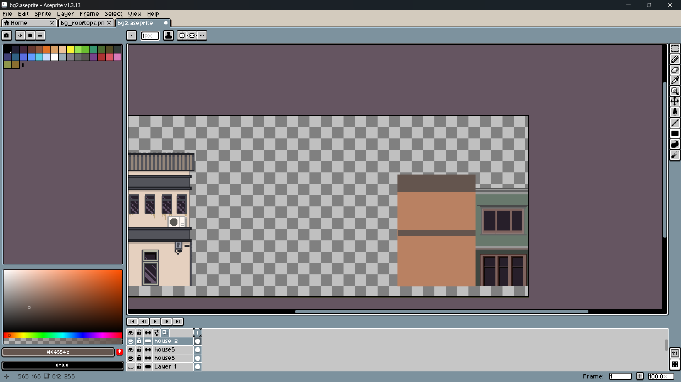

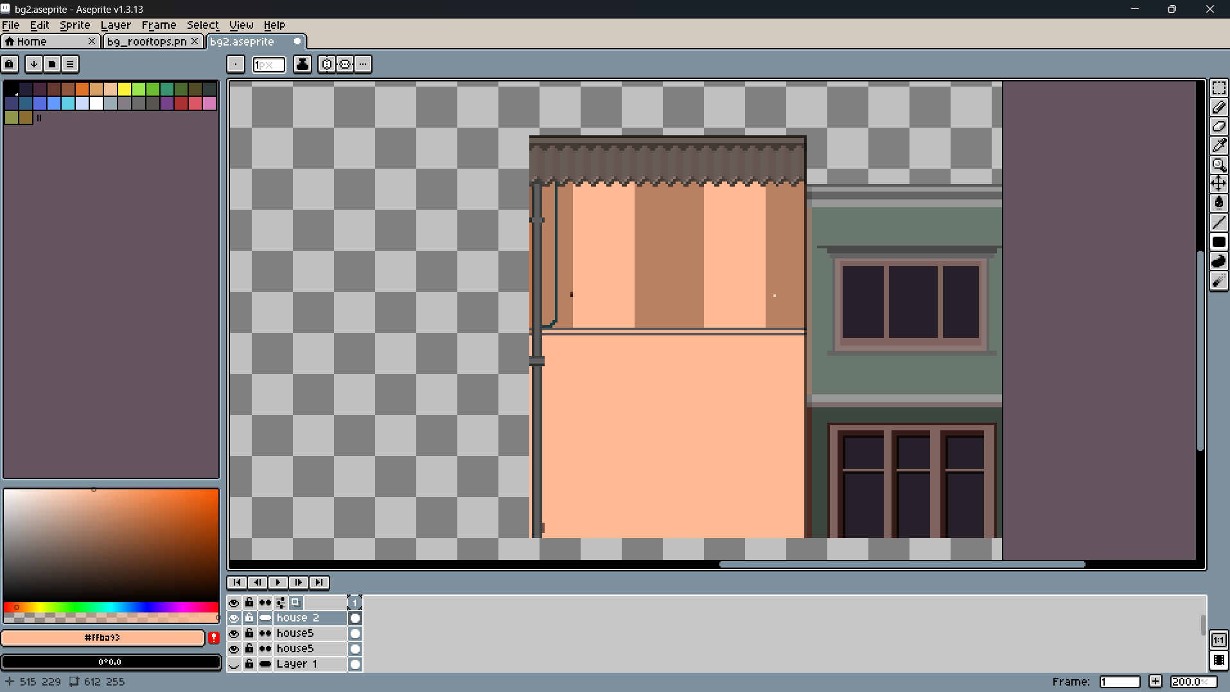

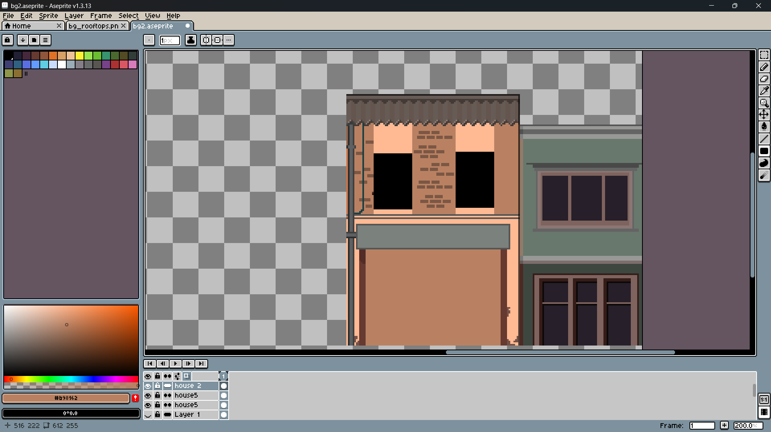

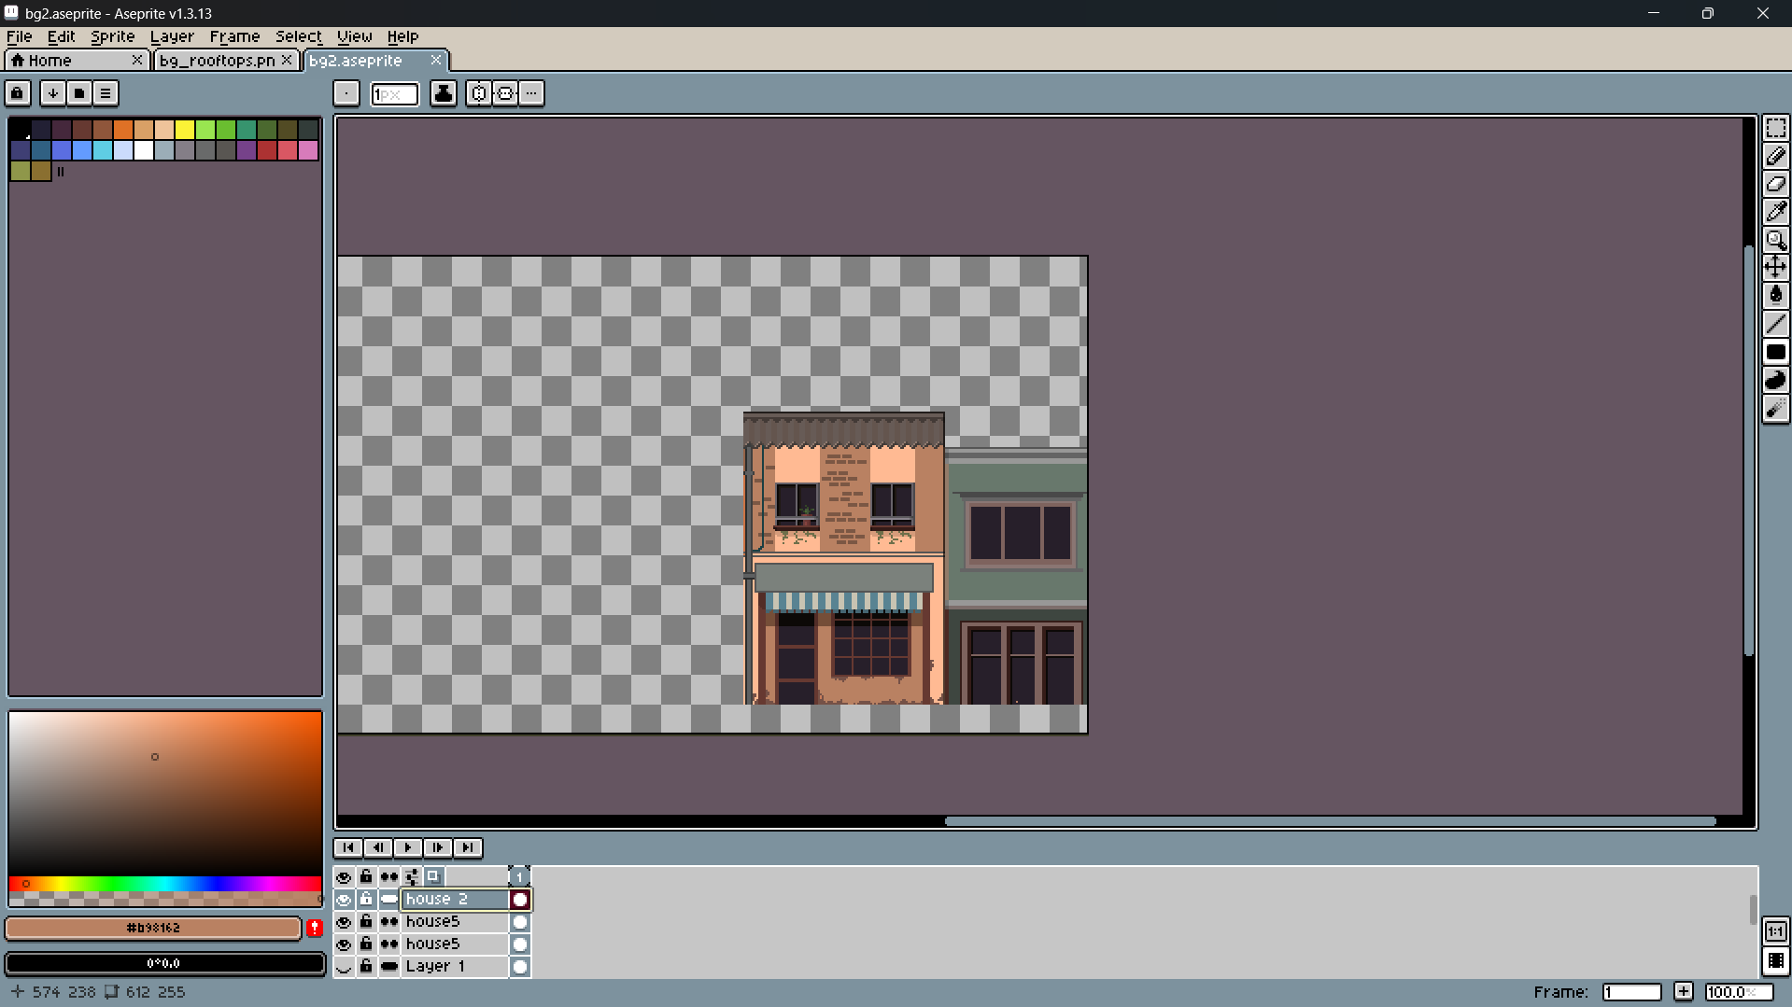

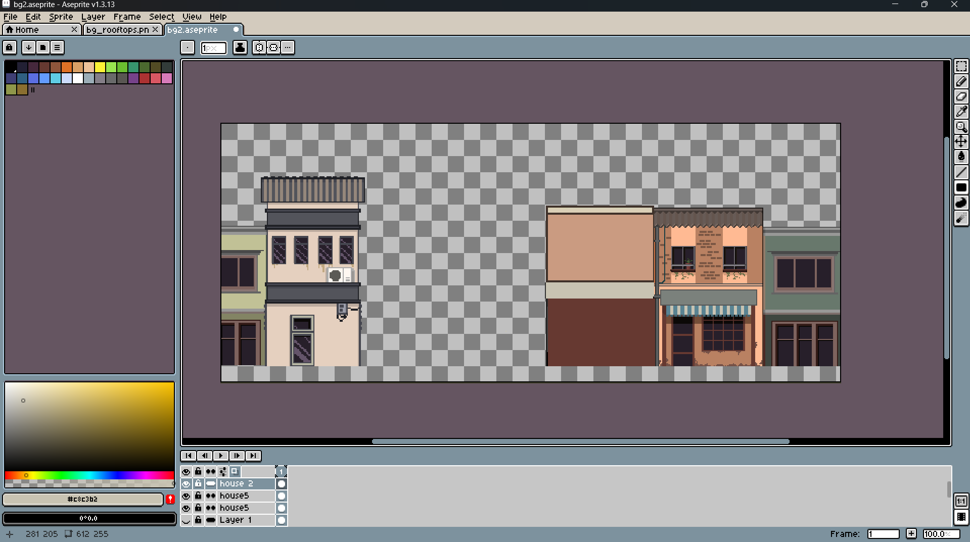

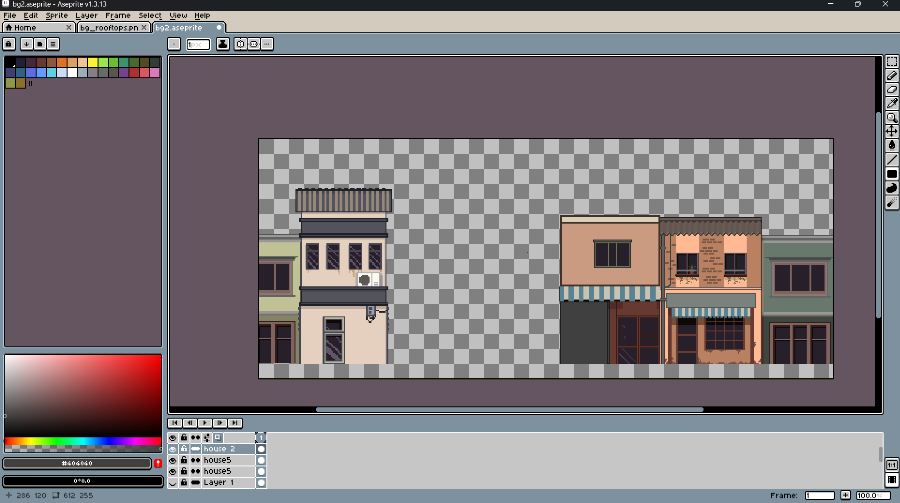

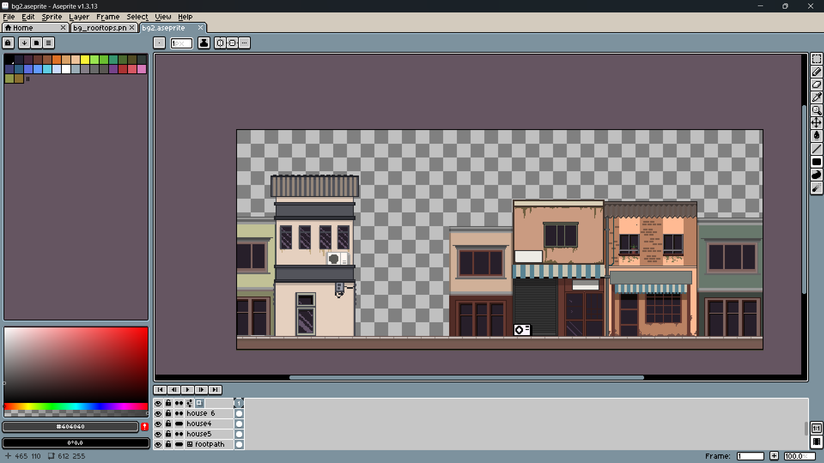

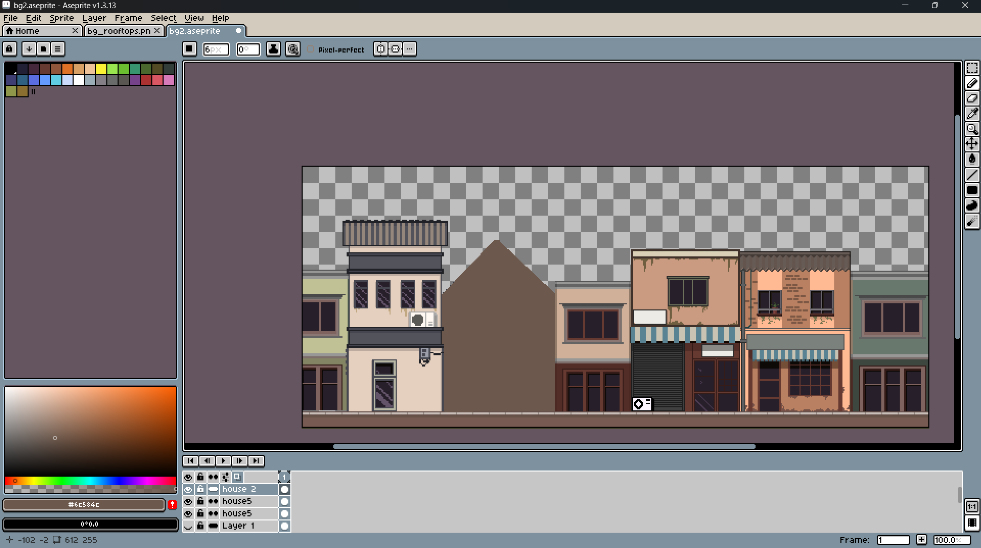

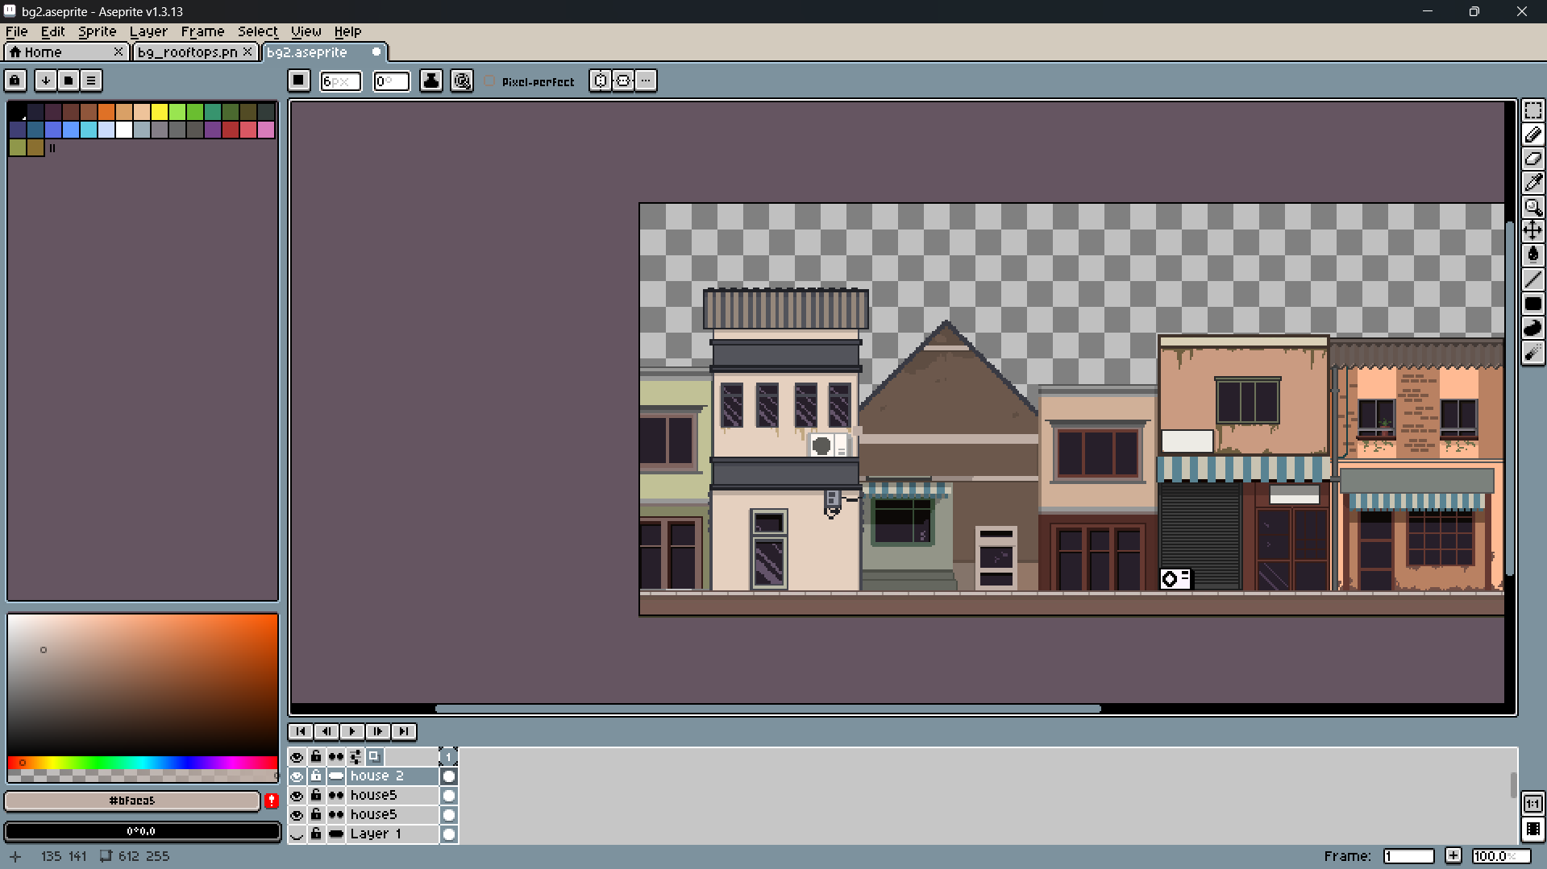

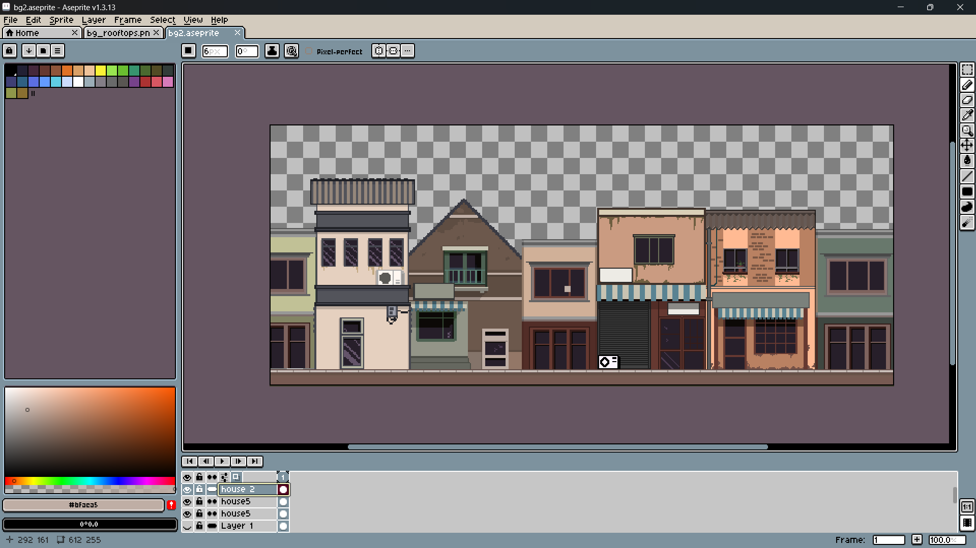

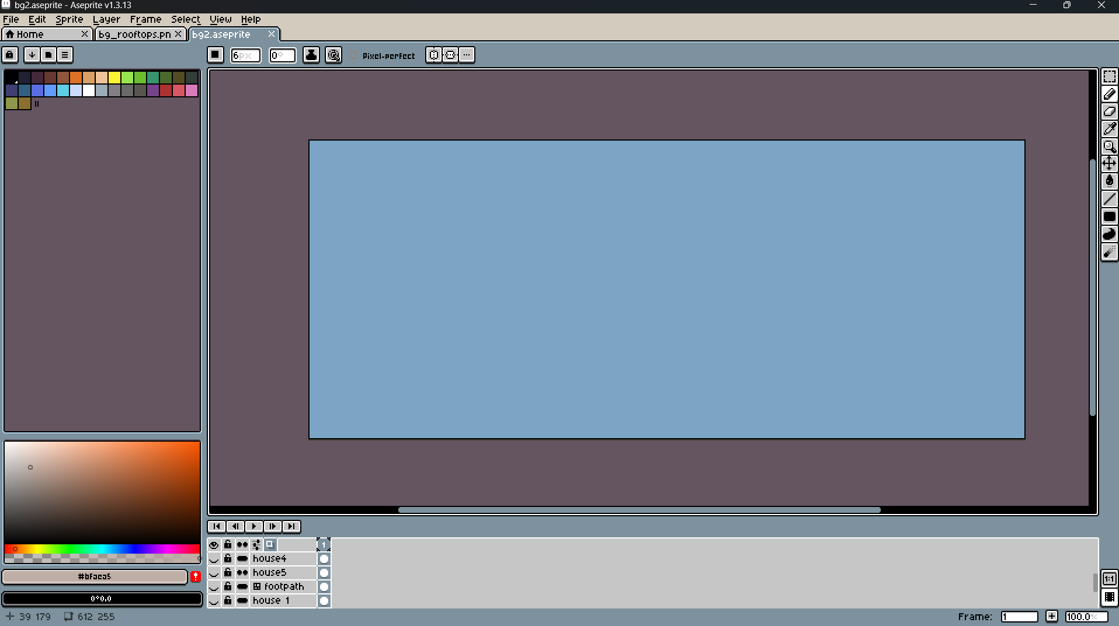

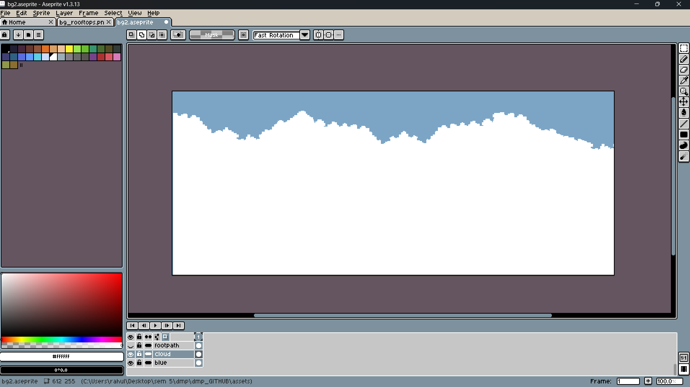

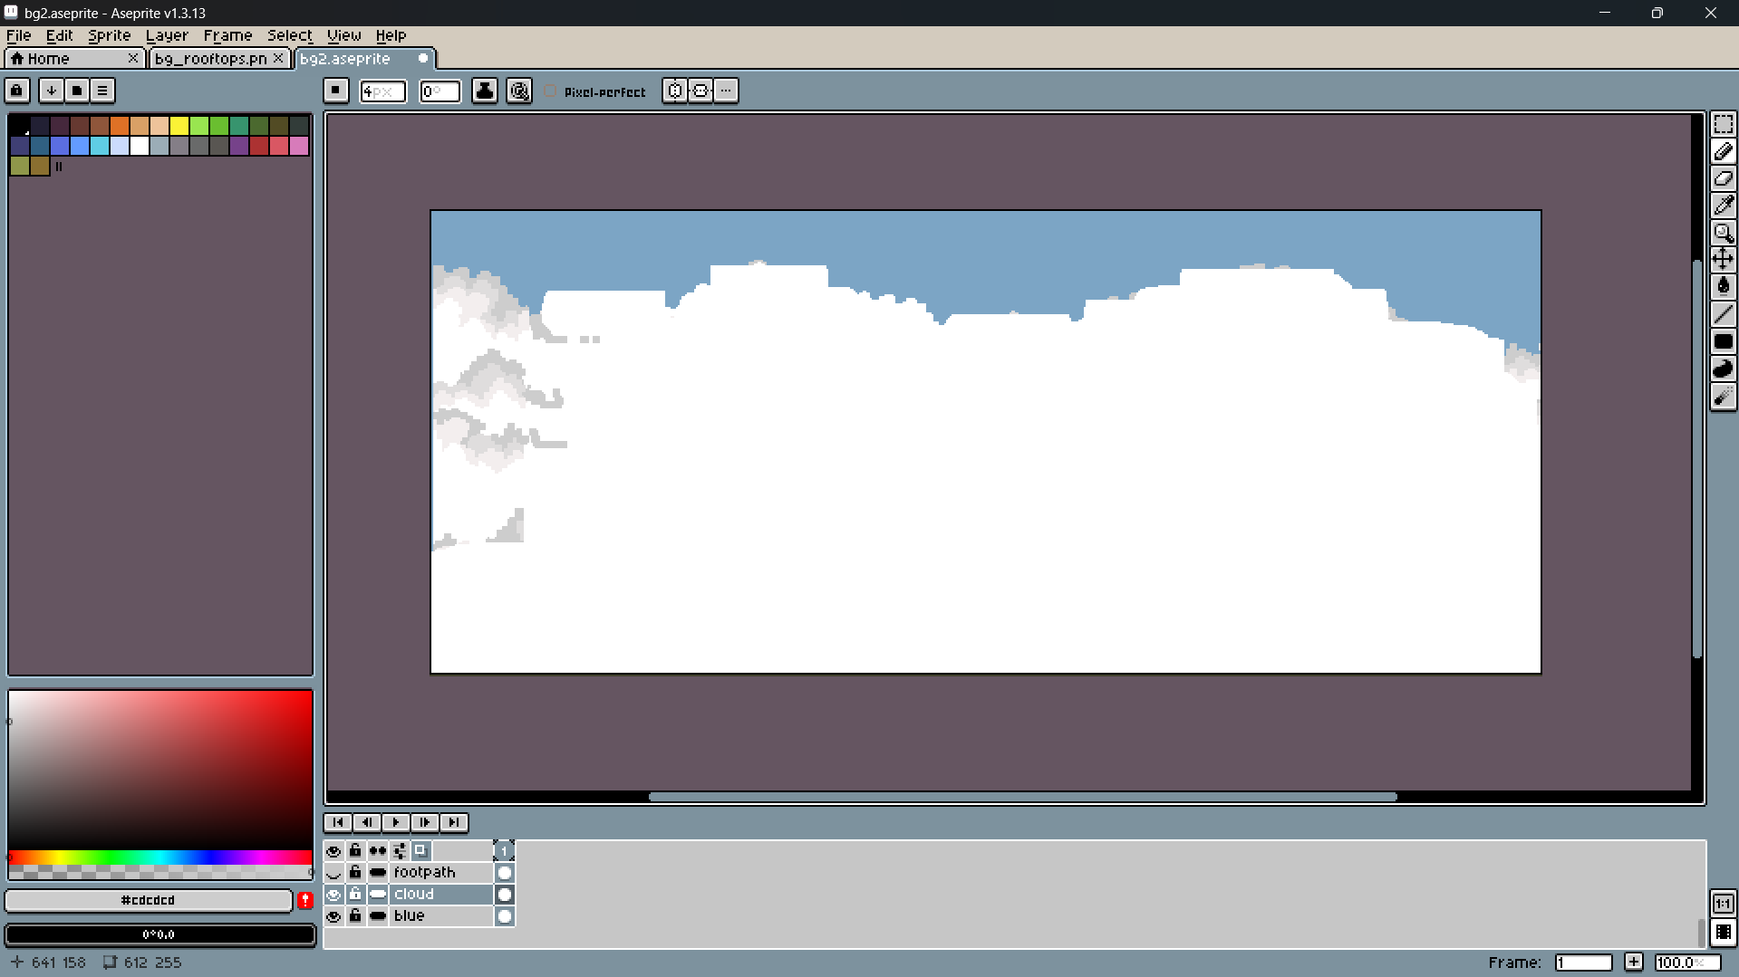

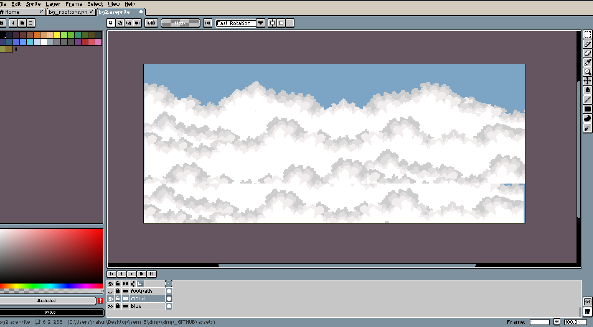

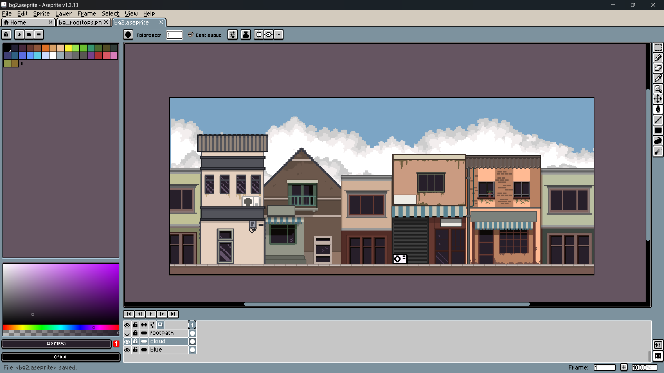

## Production Phase

### Animation

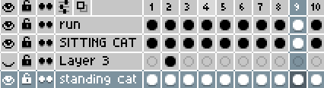

### Main character animation

1. Idle animation

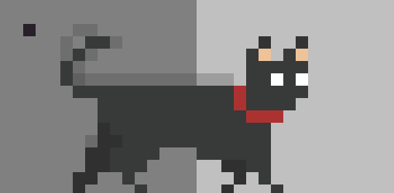

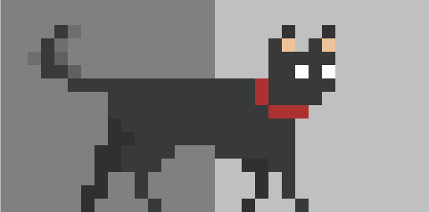

1. Run Animation

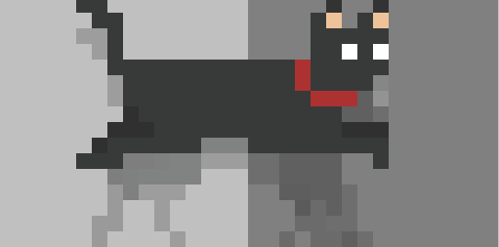

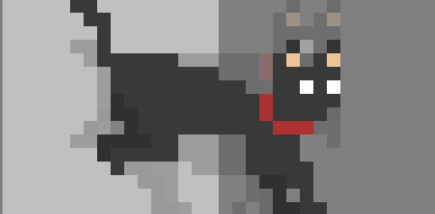

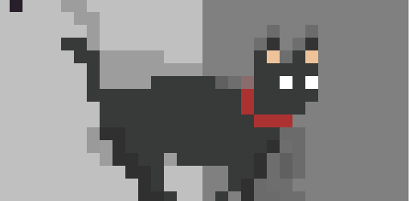

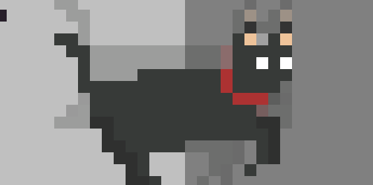

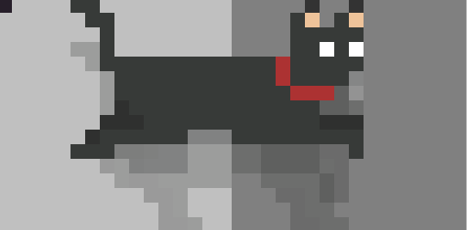

1. Attack Animation

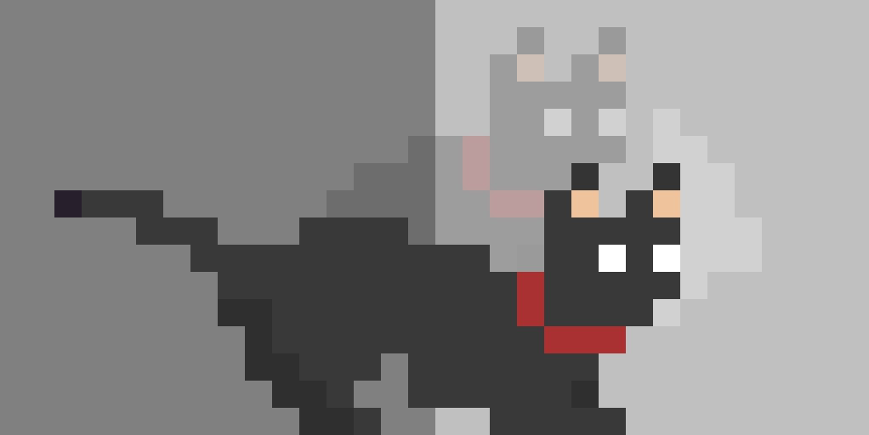



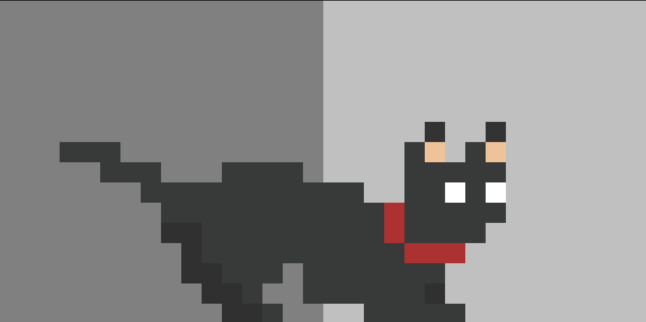

1. Sitting animation

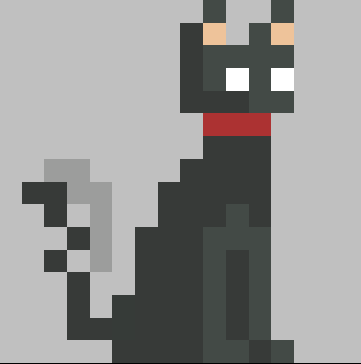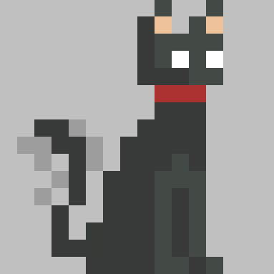

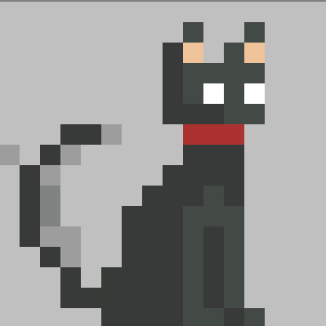

1. Hurt animation

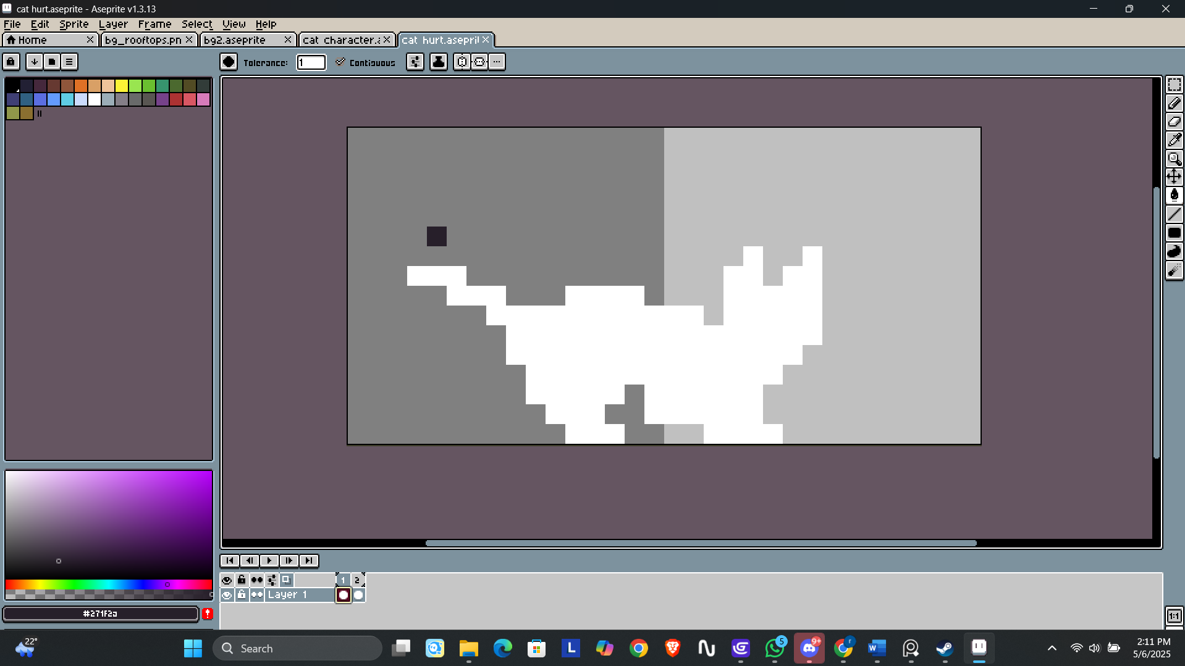

### Dog enemy animation

1. Idle animation

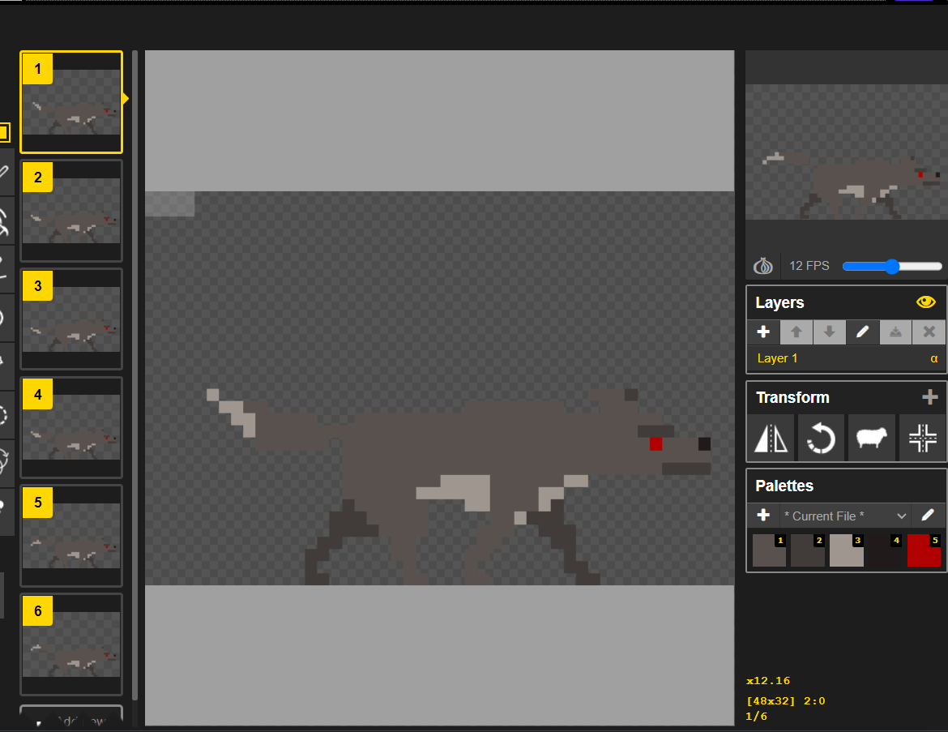

1. Run animation

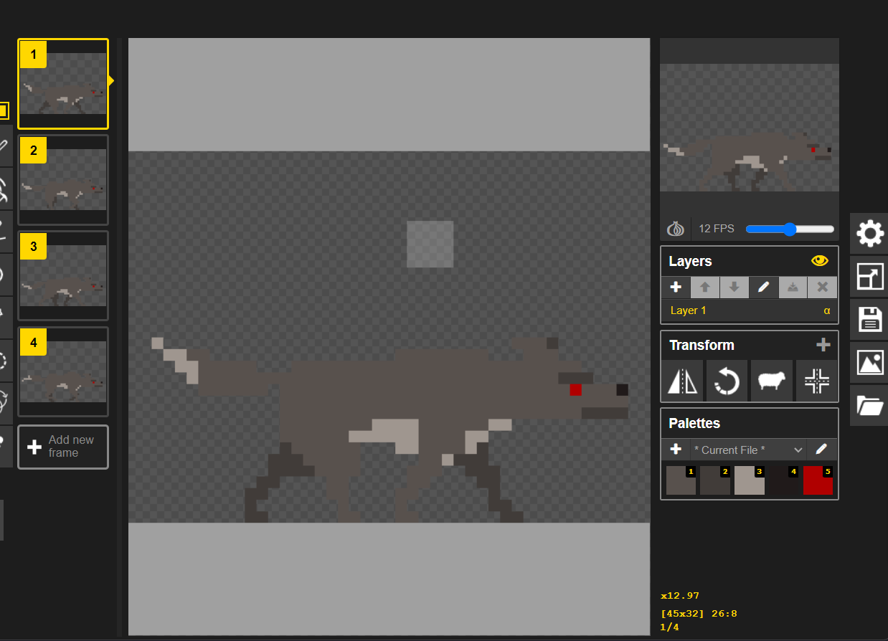

1. Attack animation

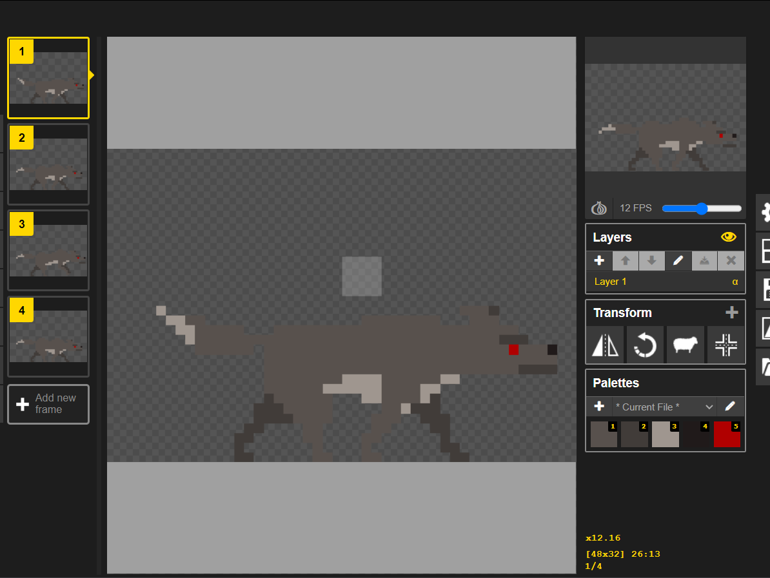

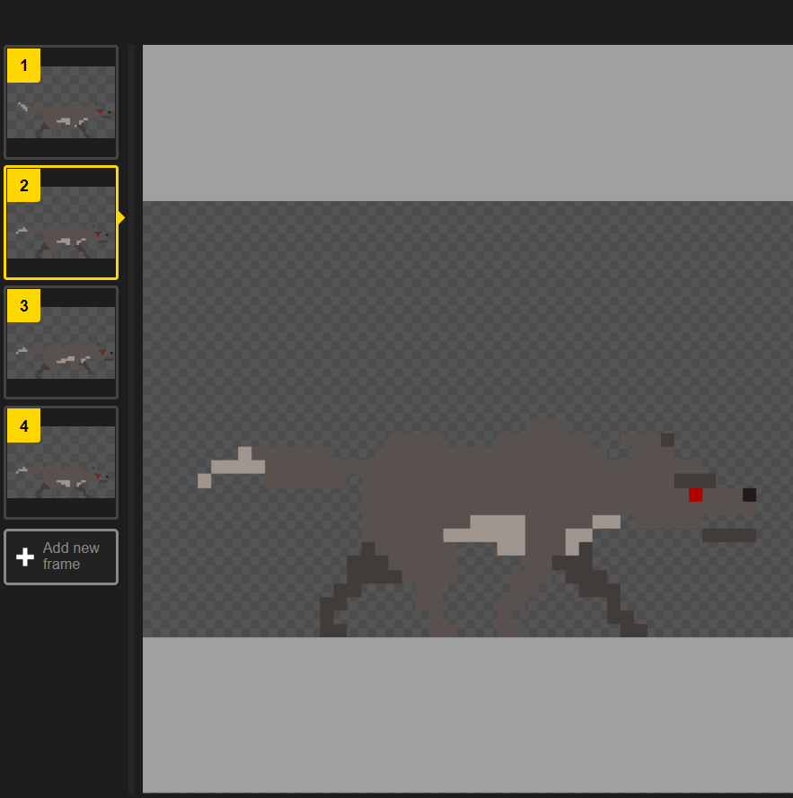

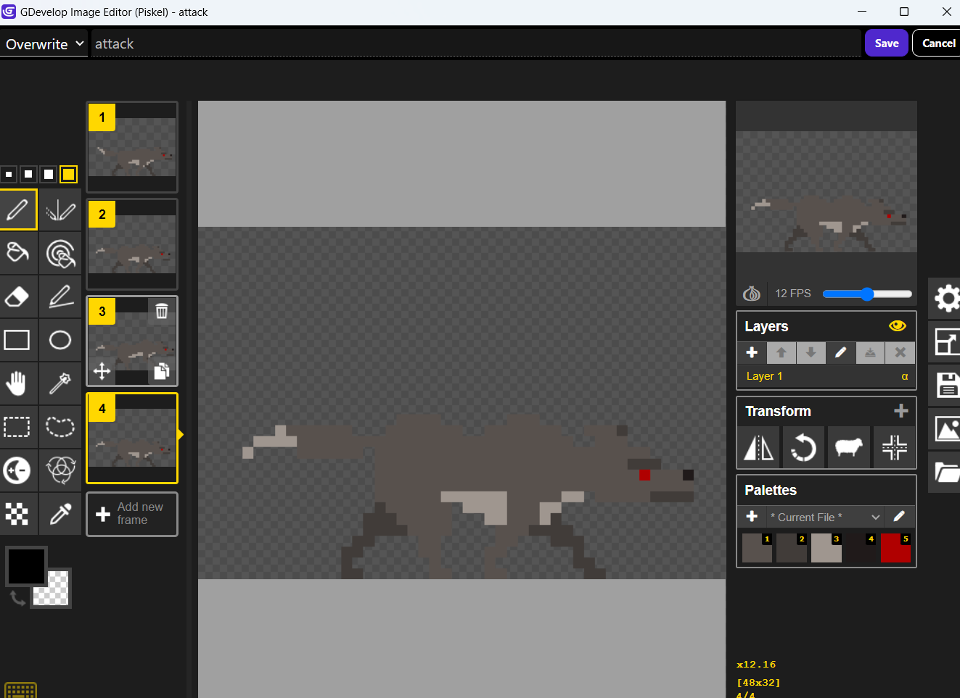

1. Hurt animation

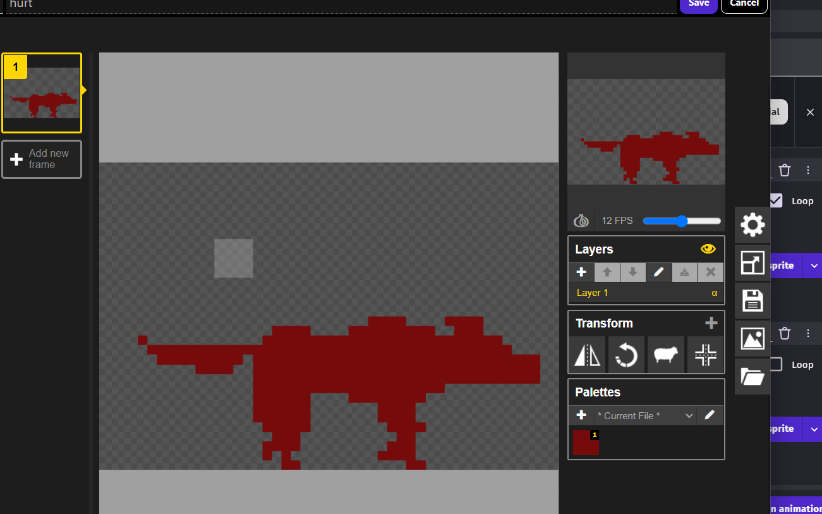

### Character Development( behaviour/Coding)

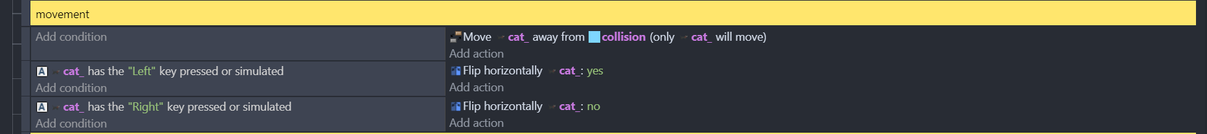

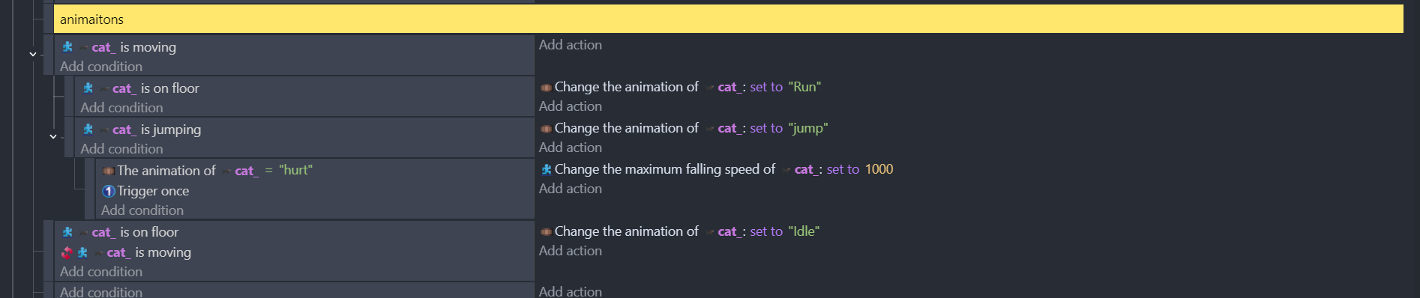

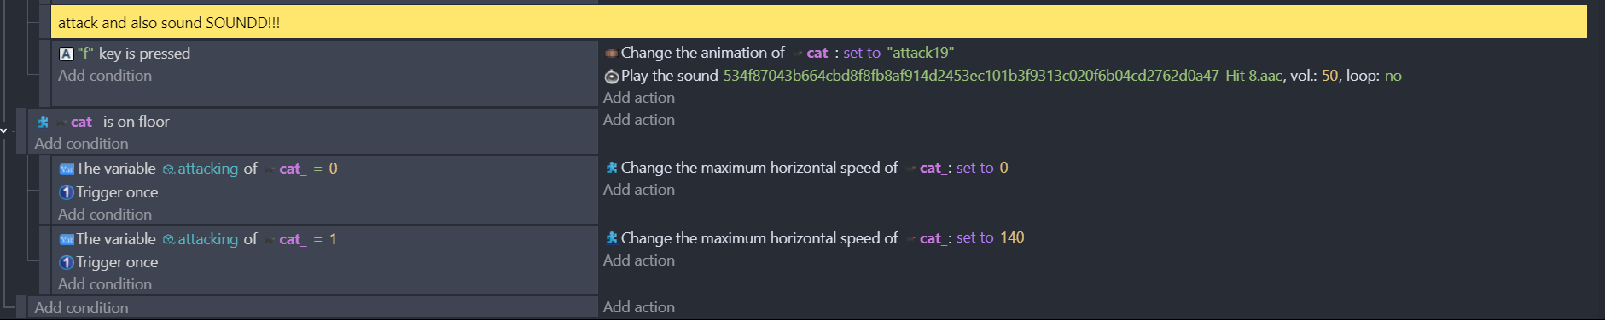

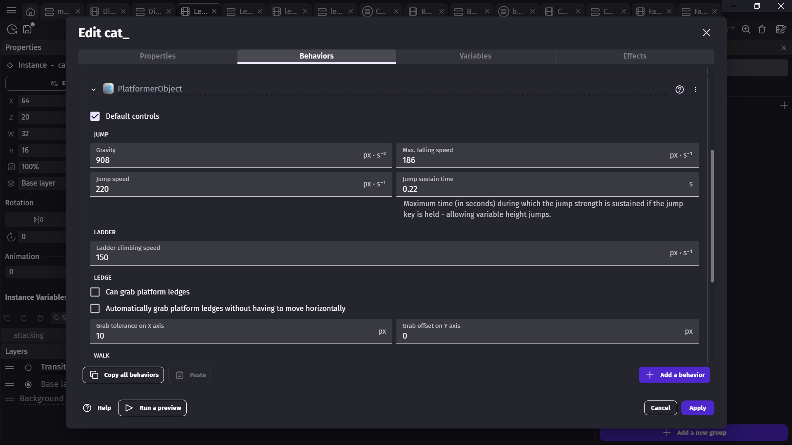

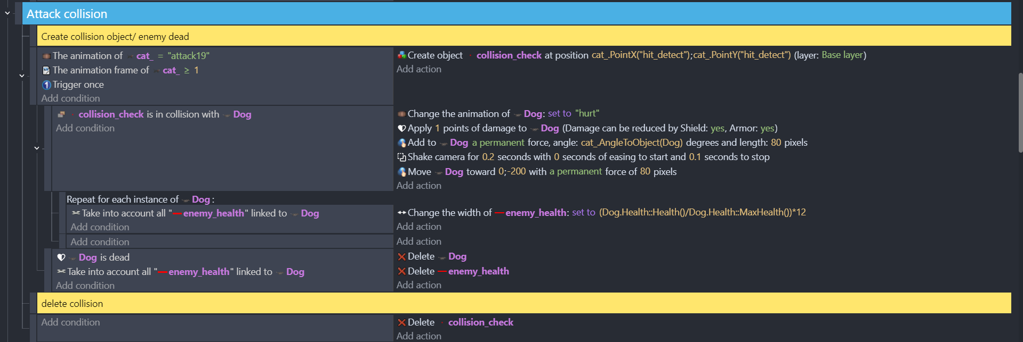

### Enemy AI

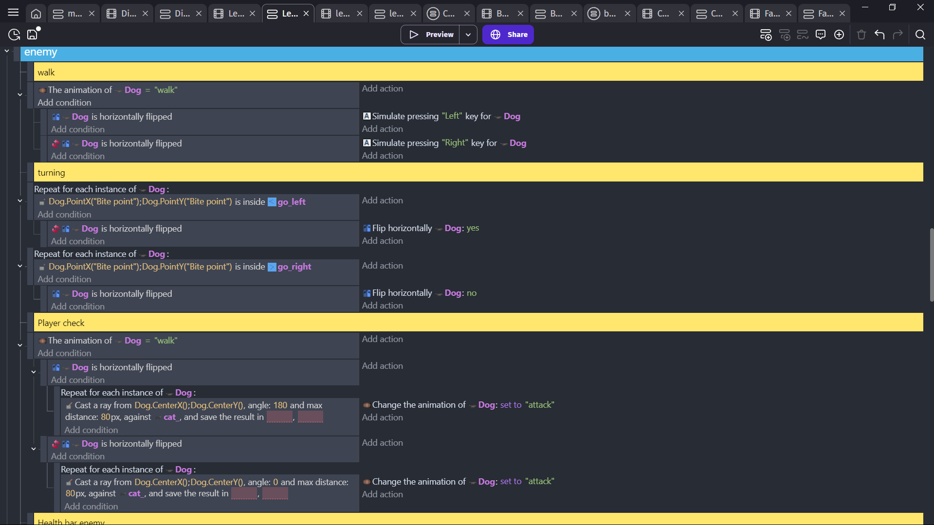

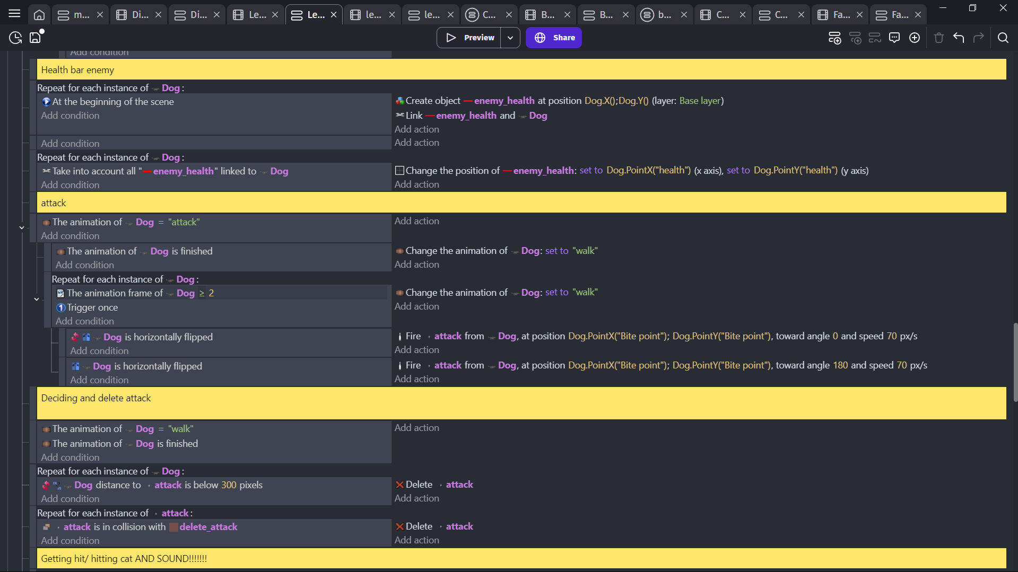

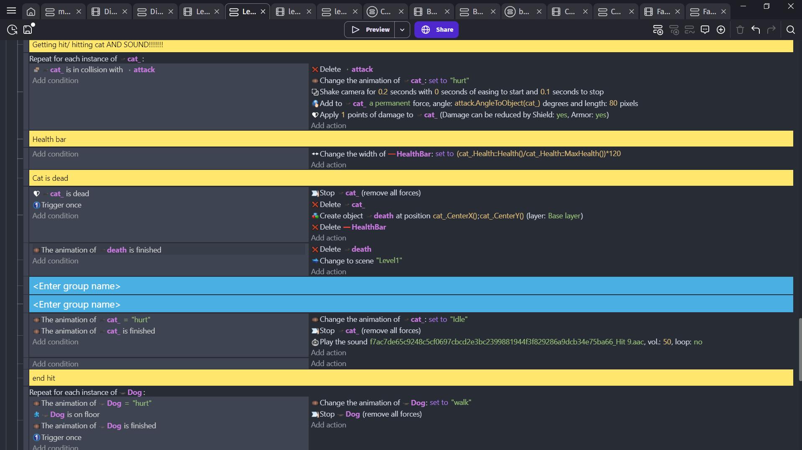

### User Interface

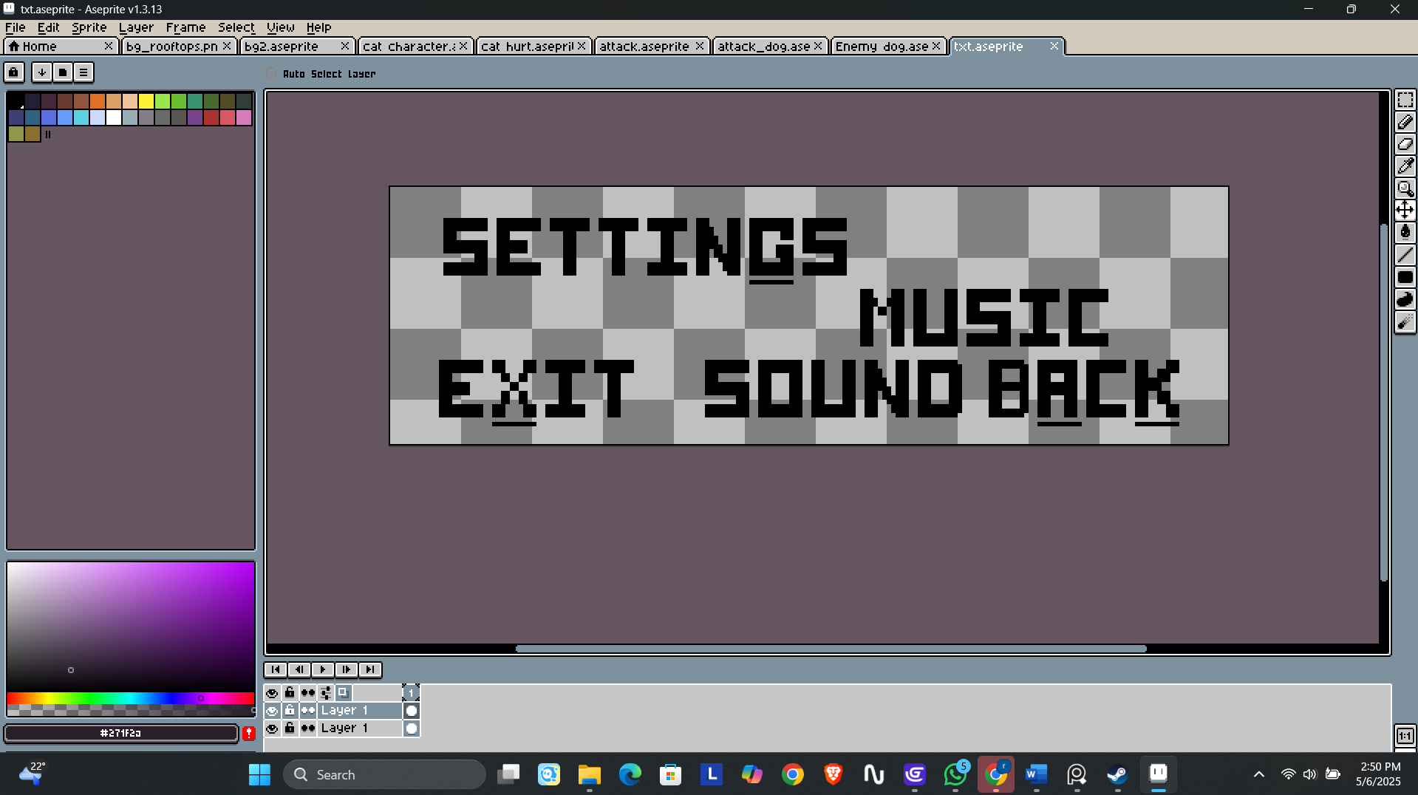

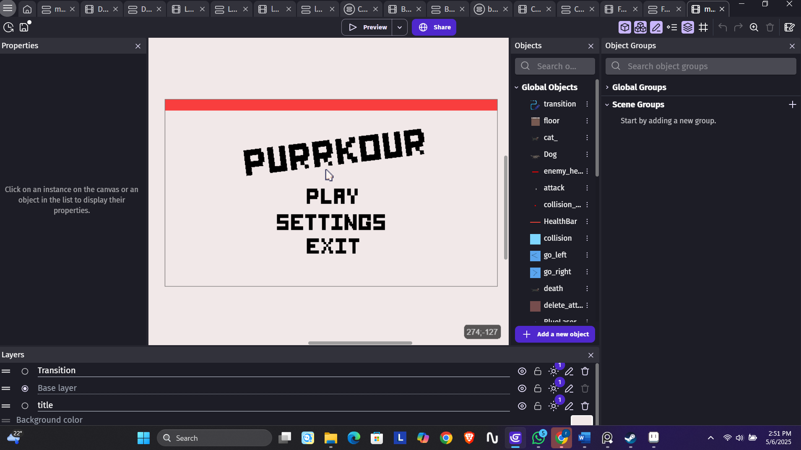

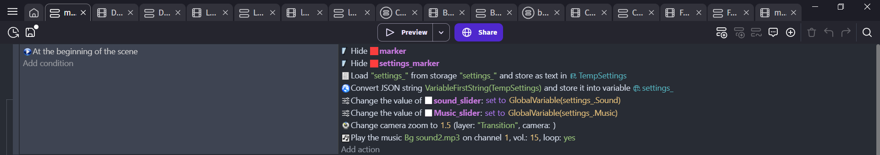

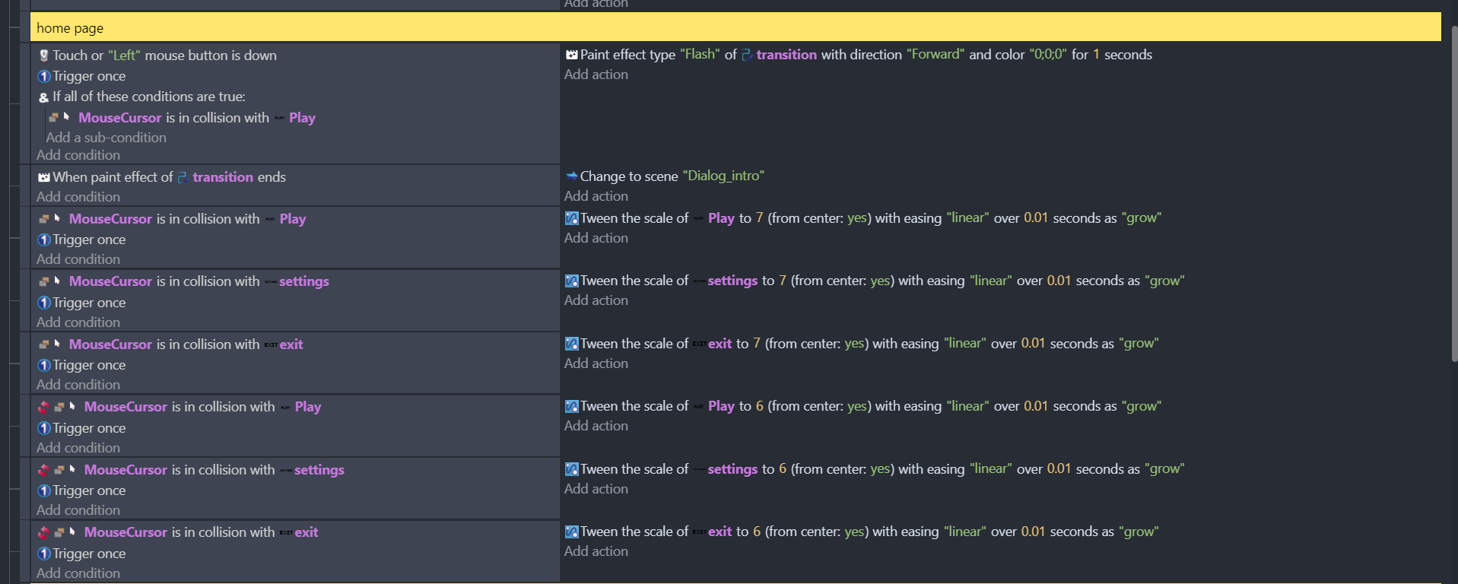

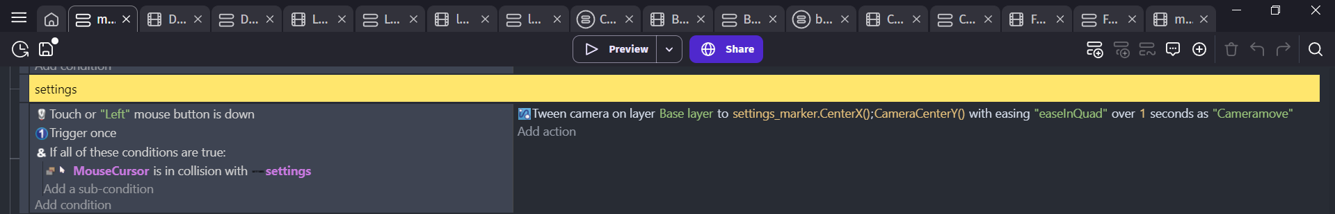

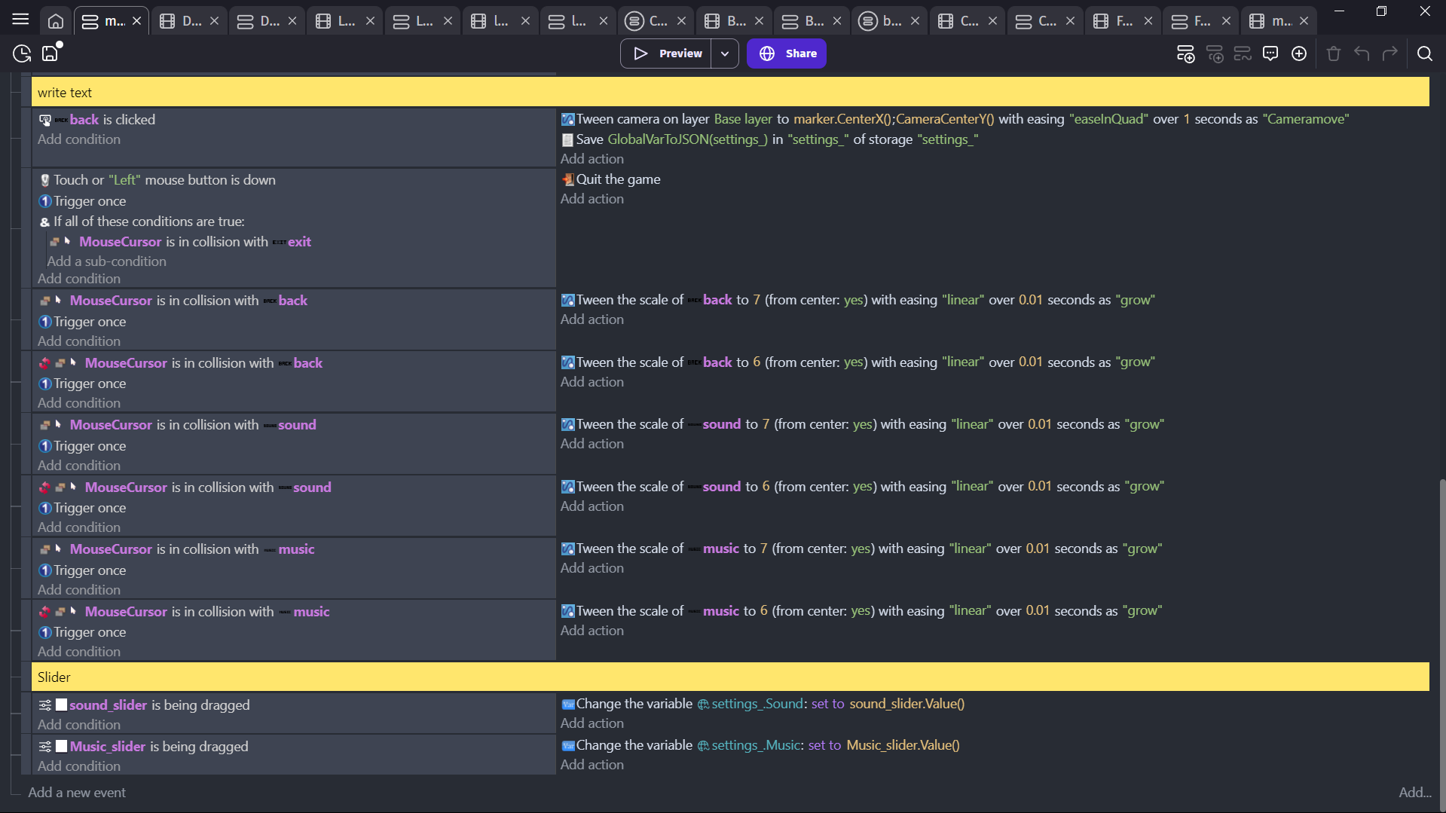

### Sound Effect

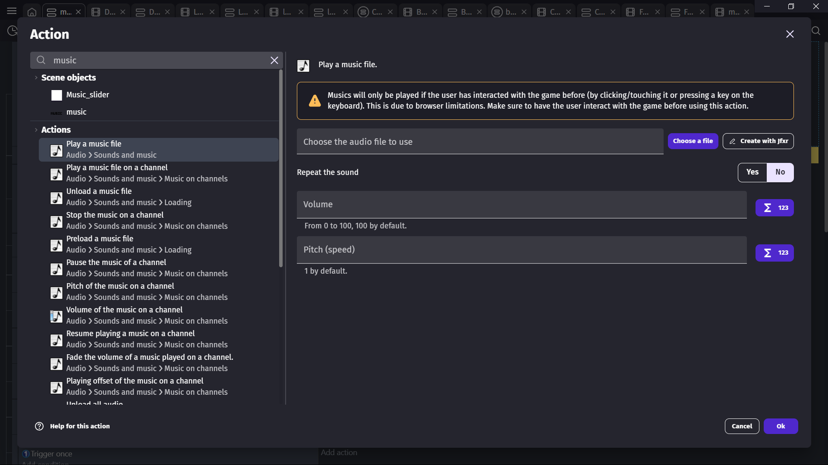



(djartmusic, 2025)

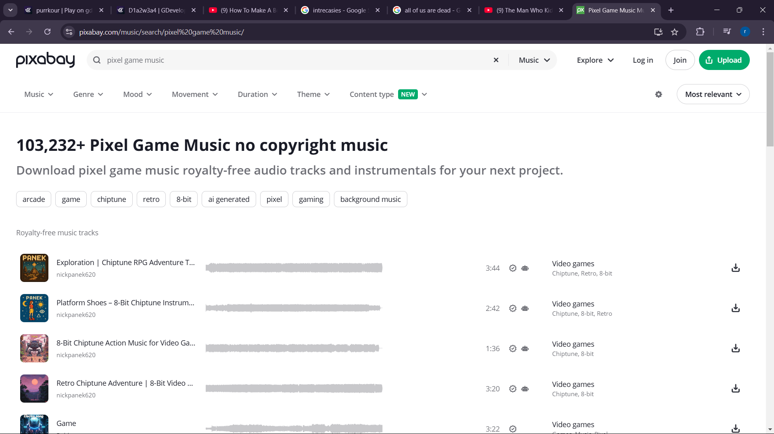

(djartmusic, 2025)

## Character Design

## Dog Character

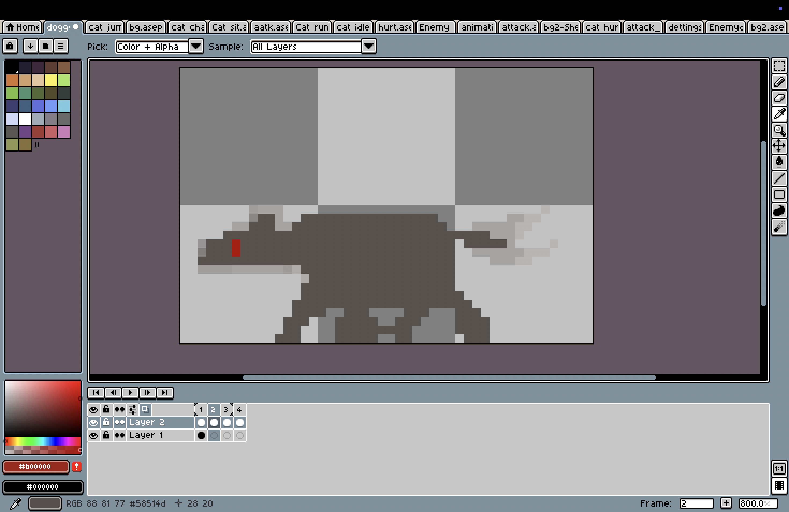

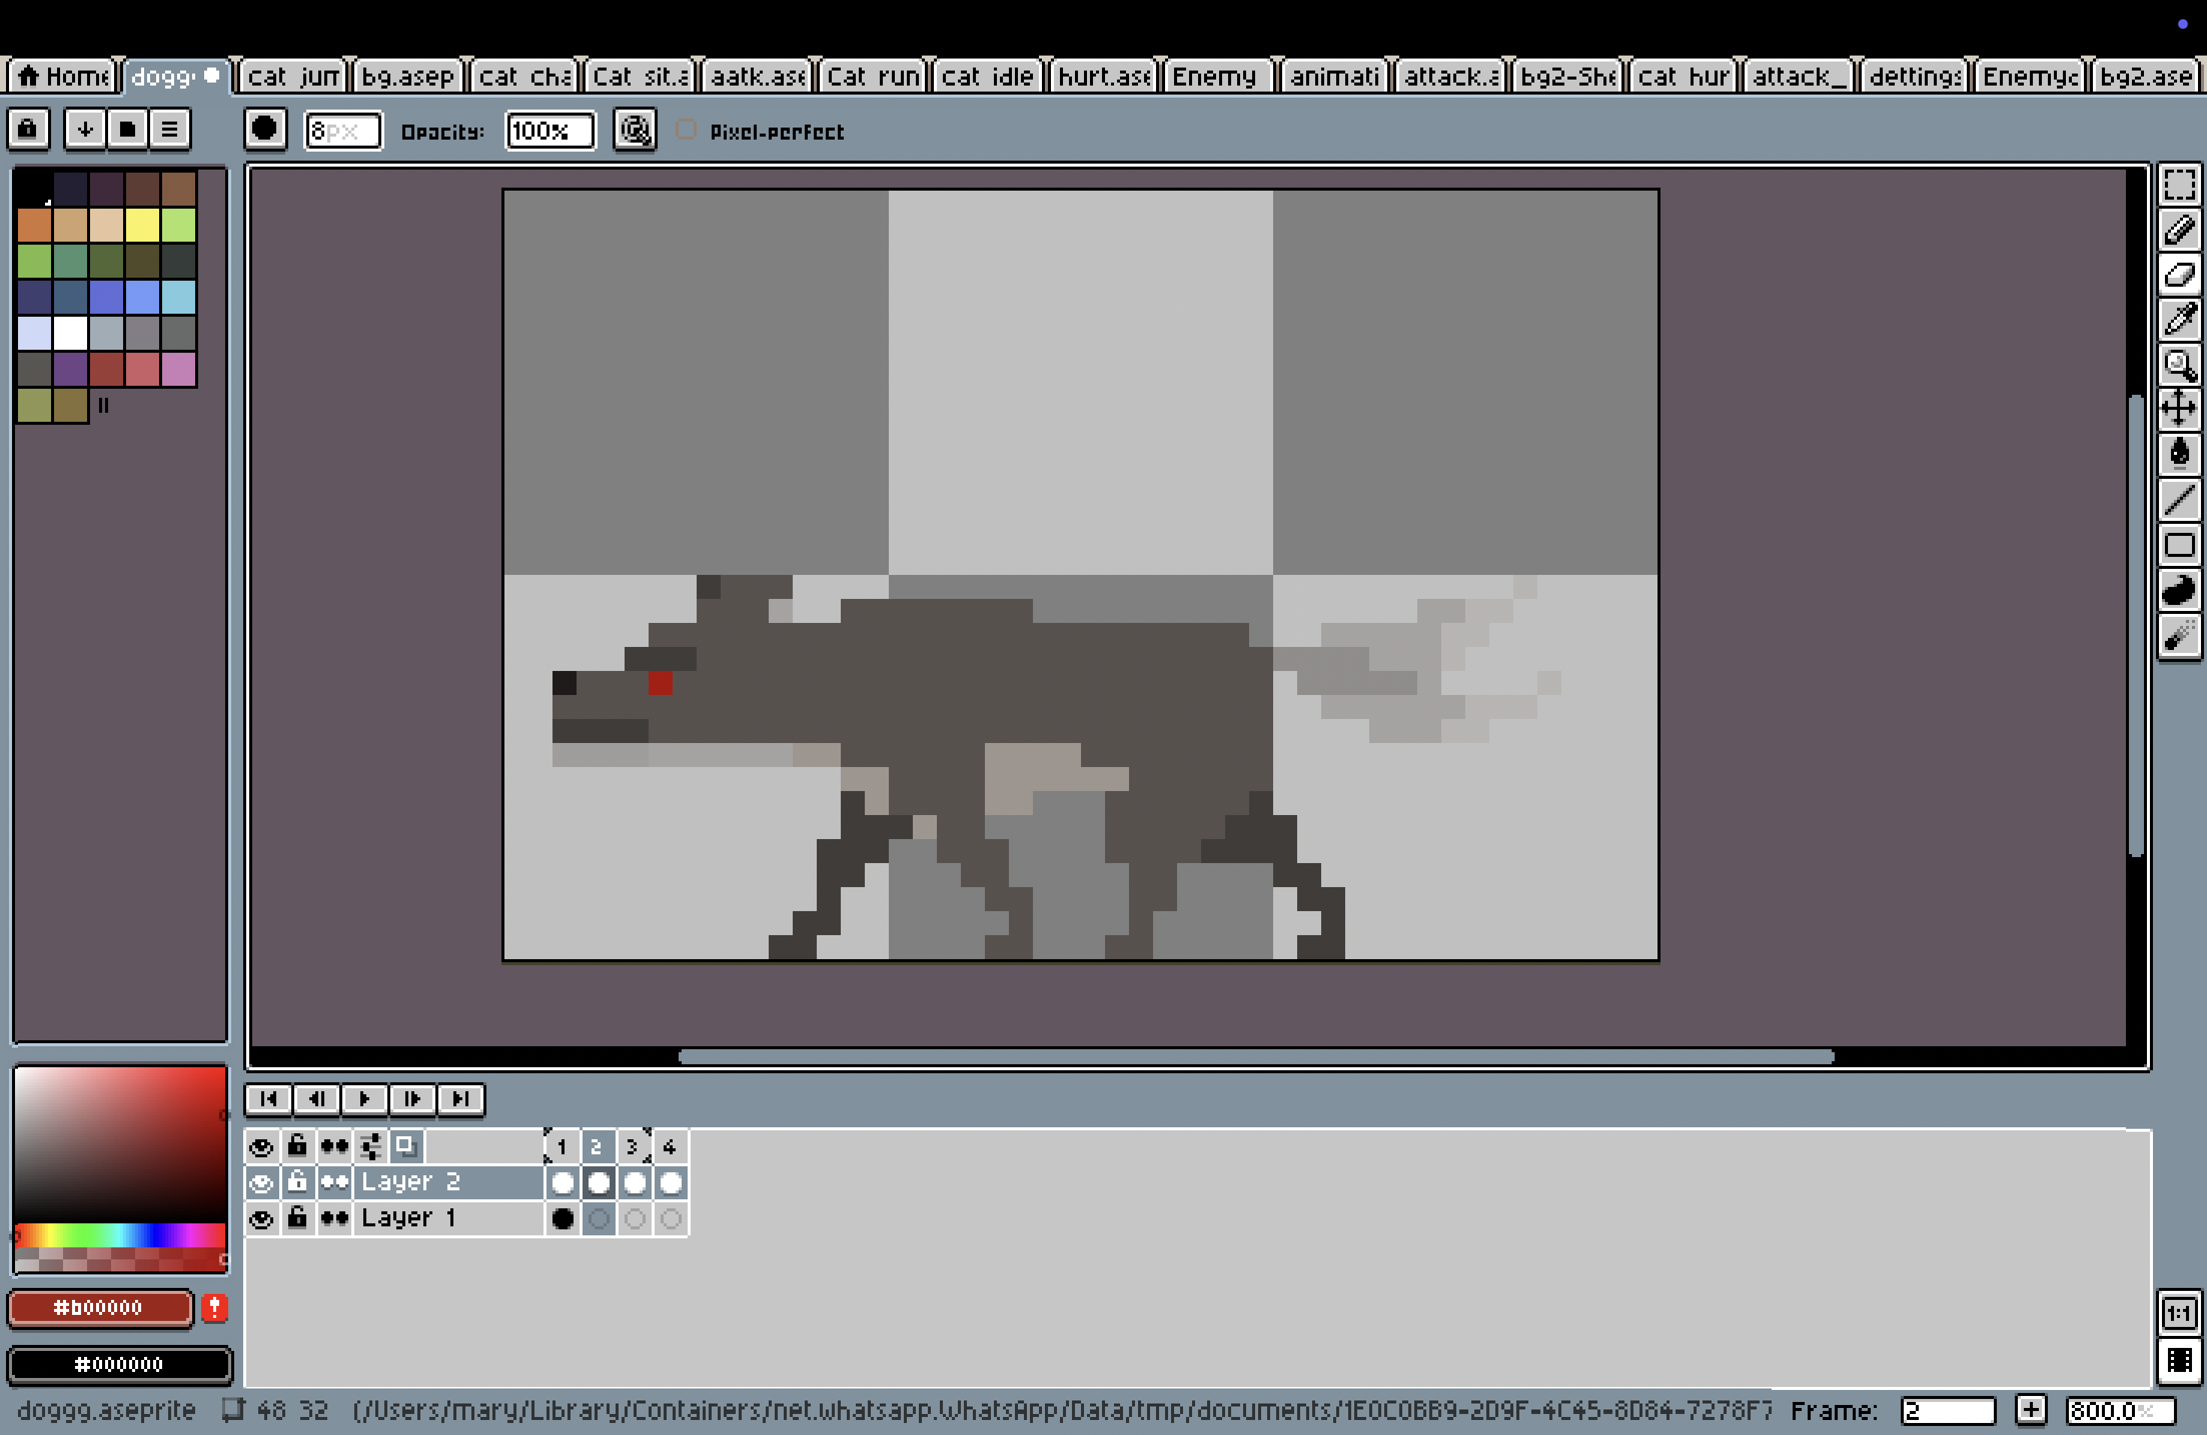

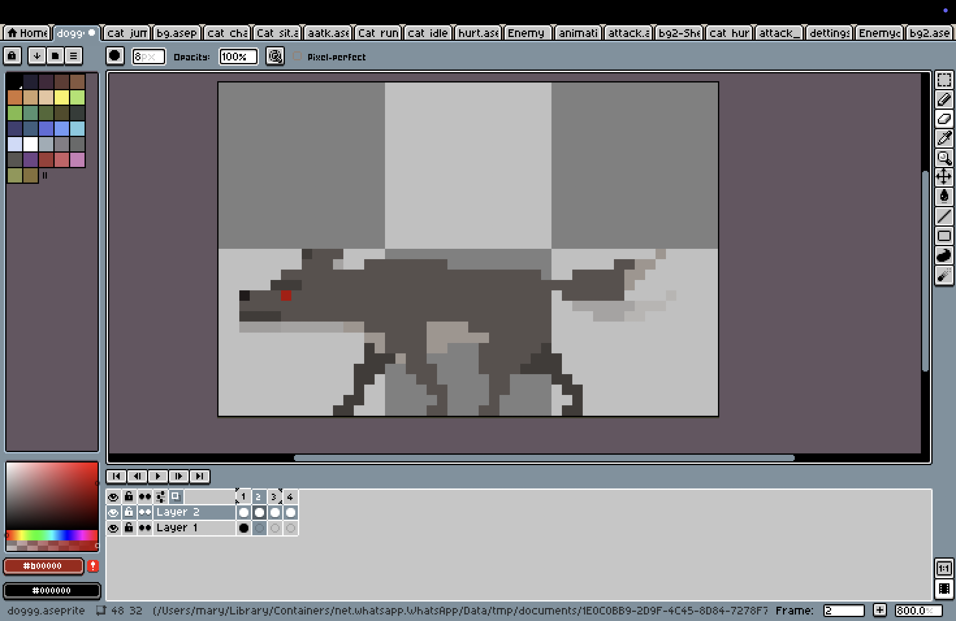

Figure 14: Process of enemy design

## Main cat character (Front and side view)

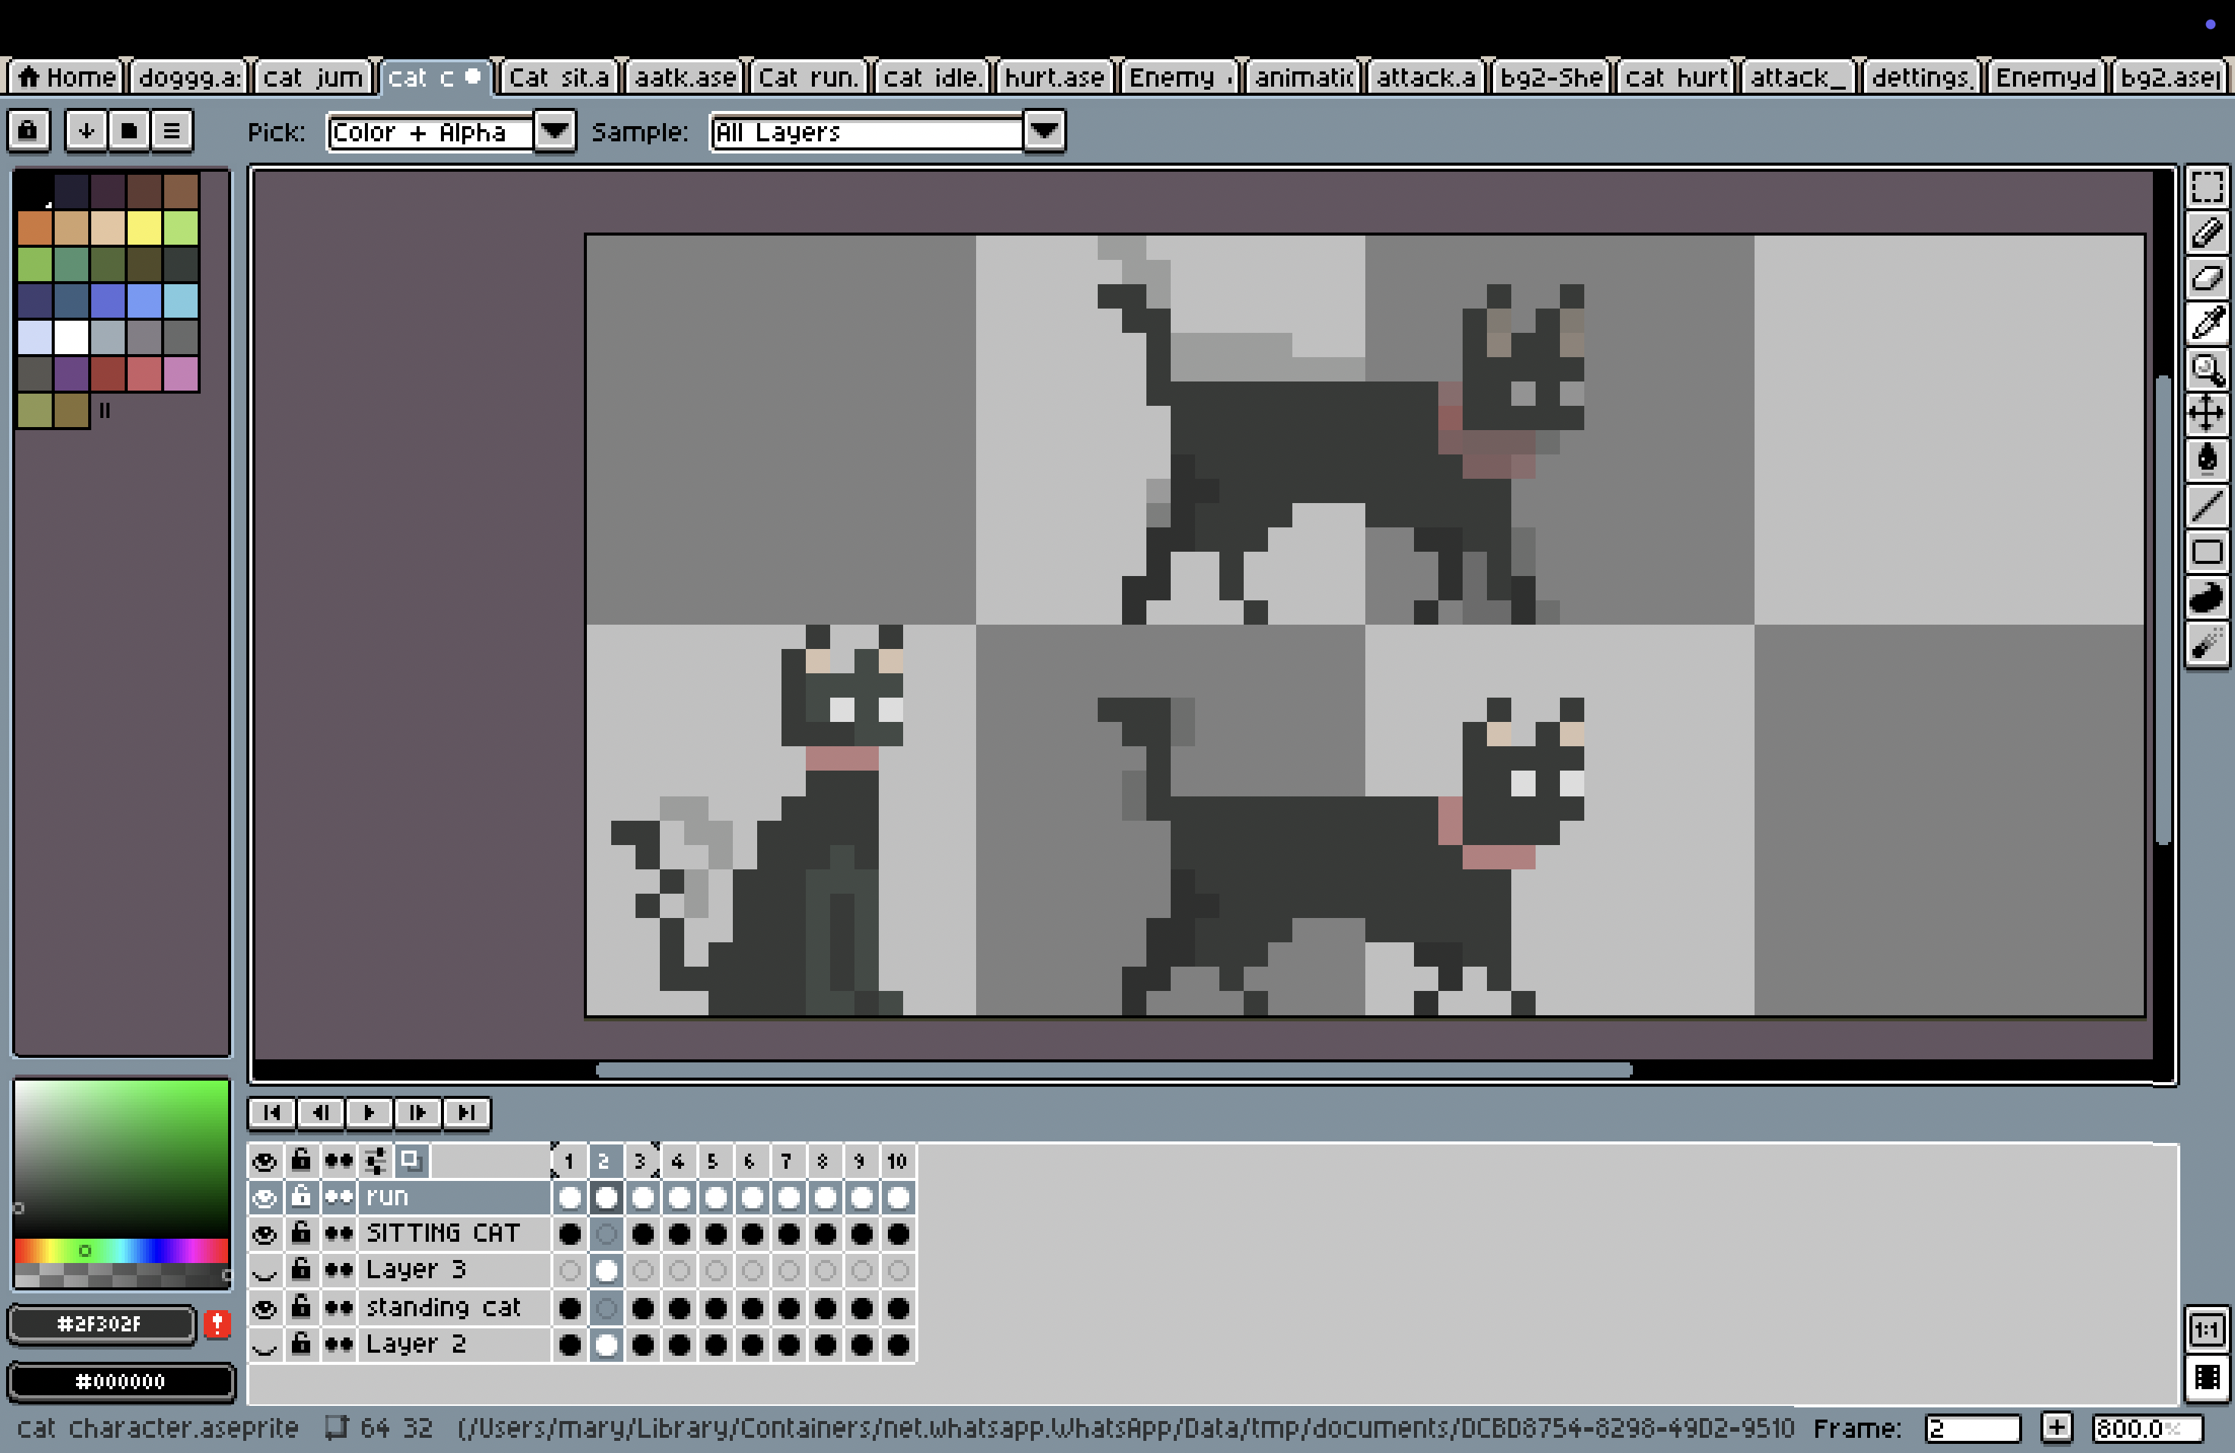

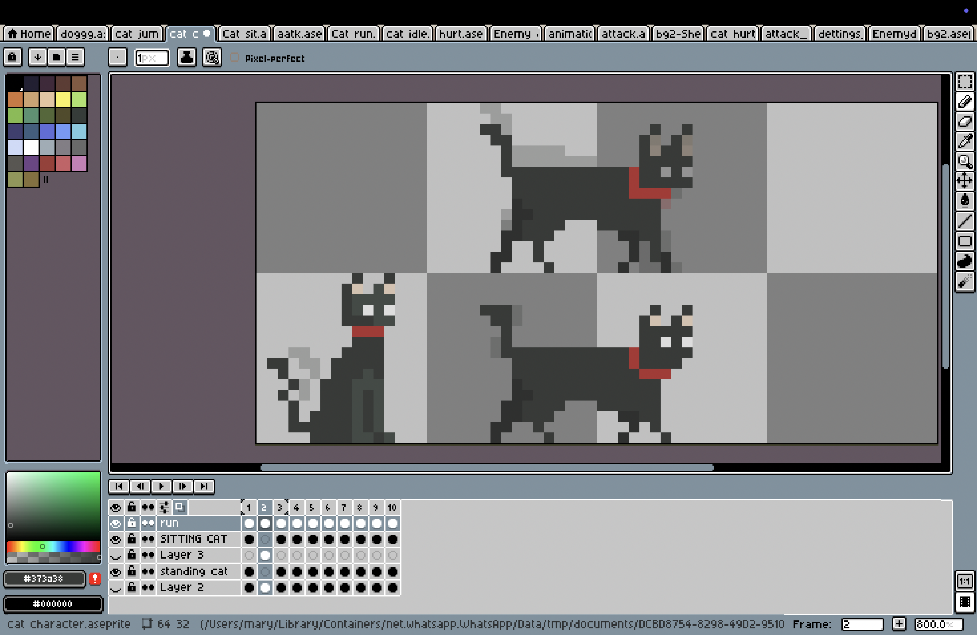



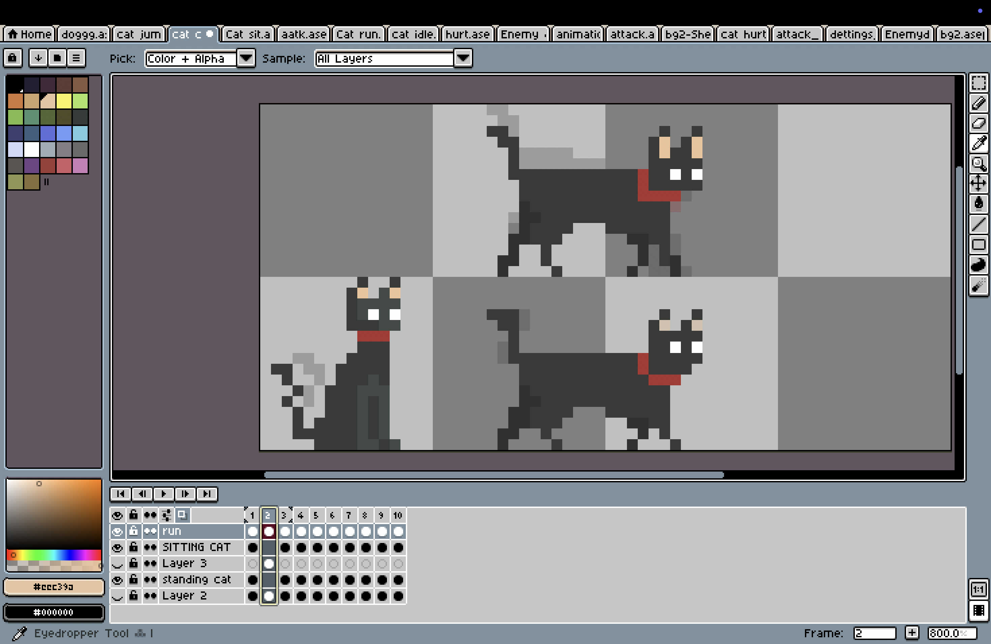

Figure 15: Process of cat design

## Cat hurt

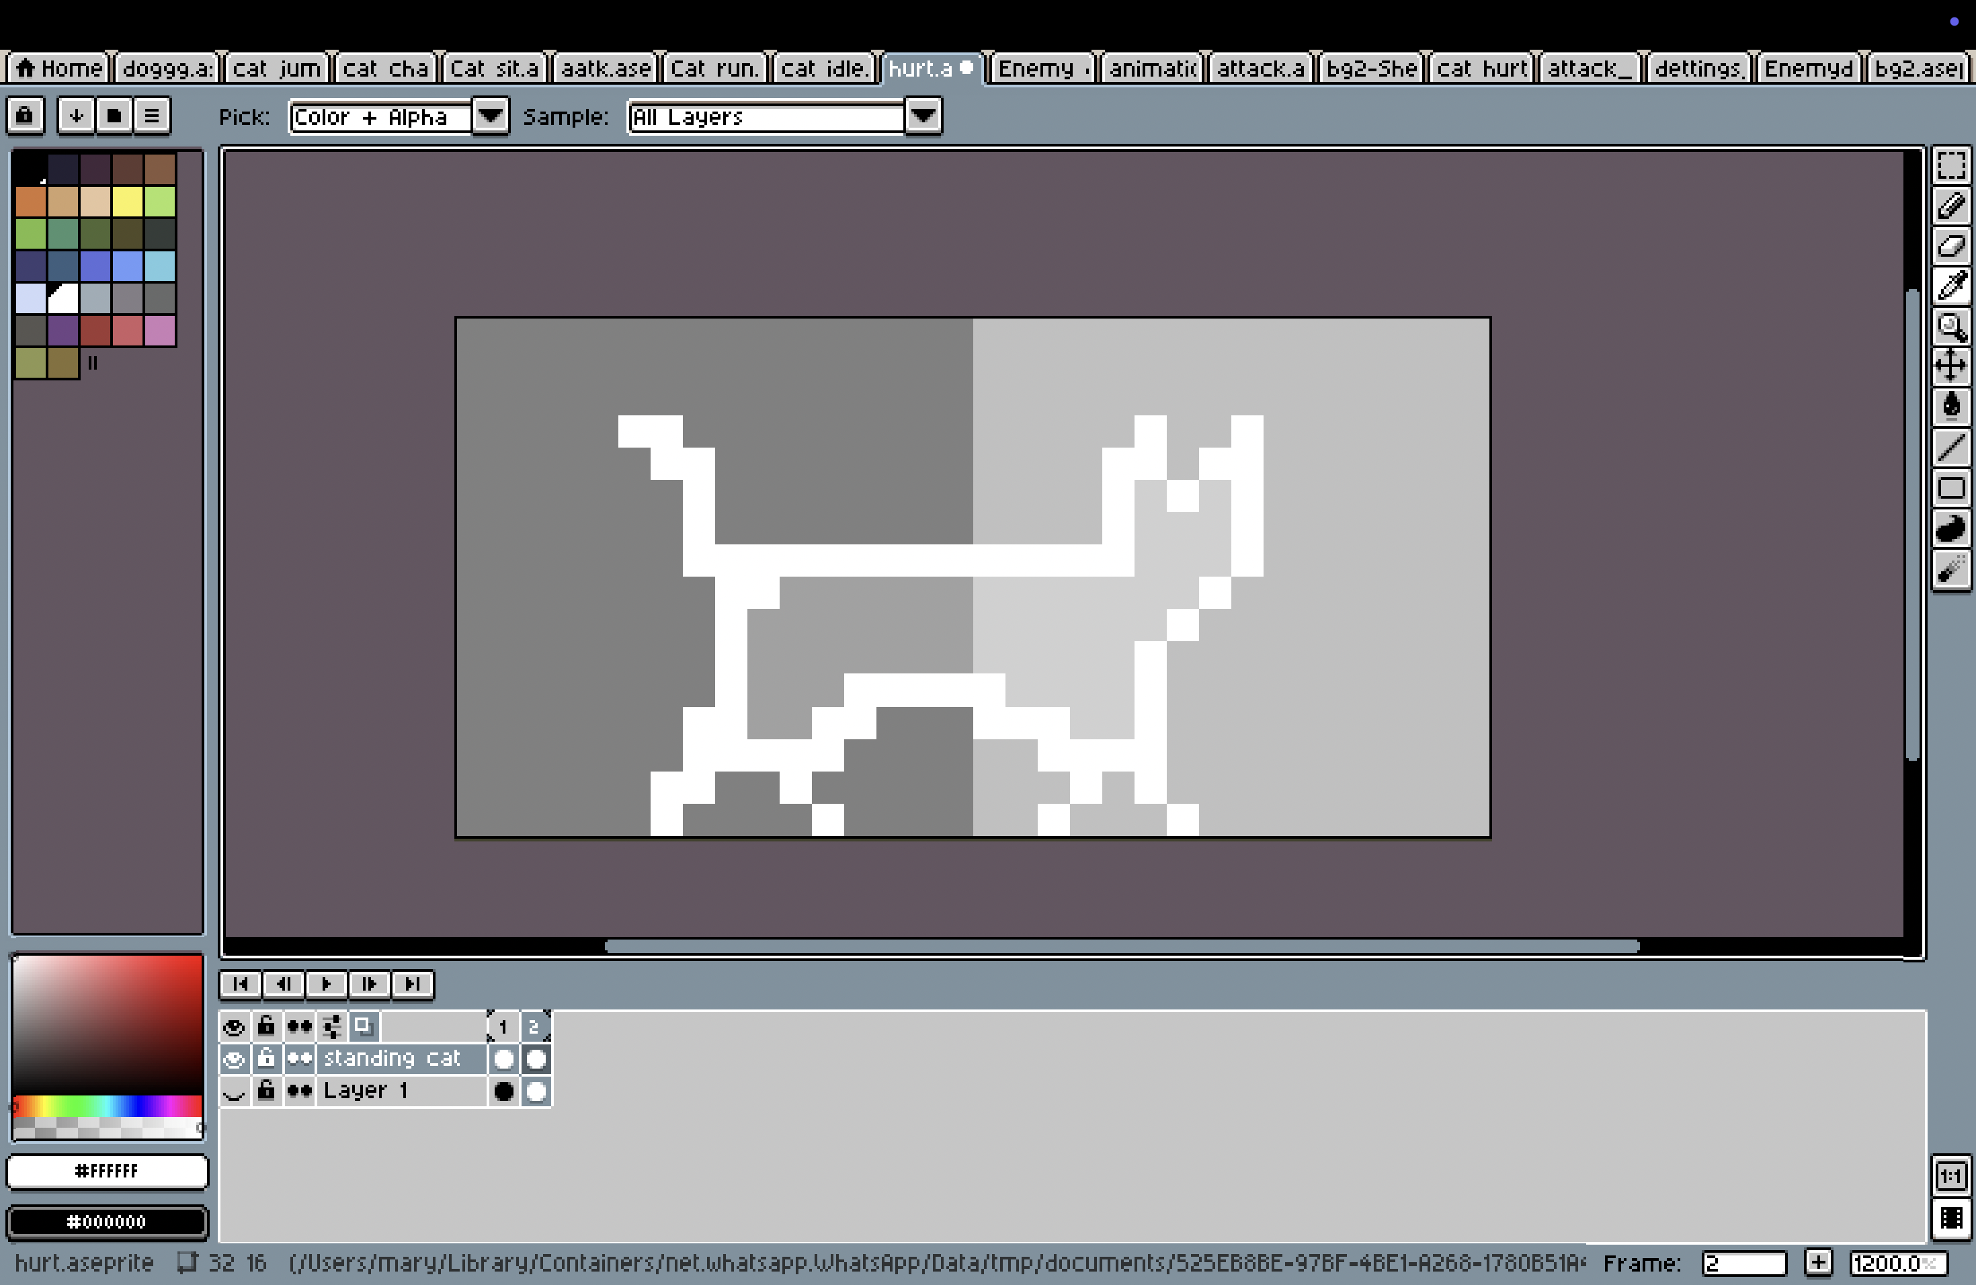

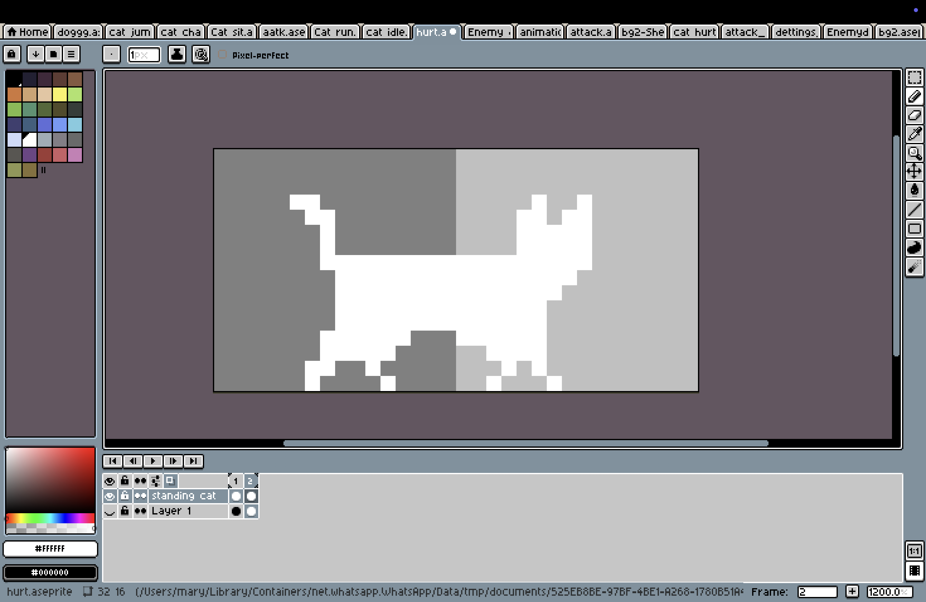

Figure 16: Process of hurt cat design

## Enemy character

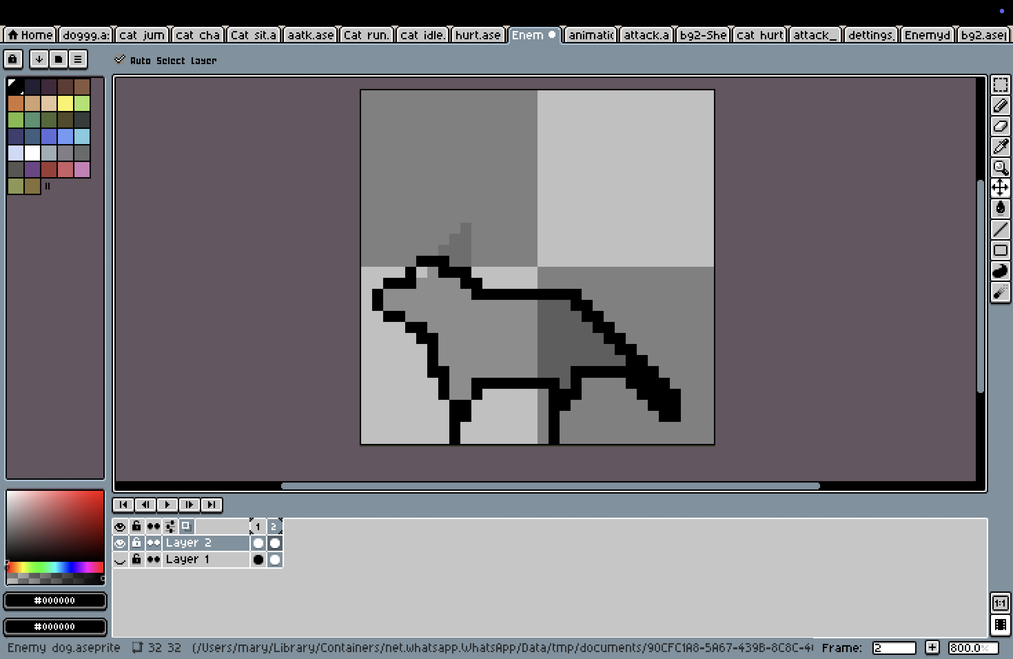

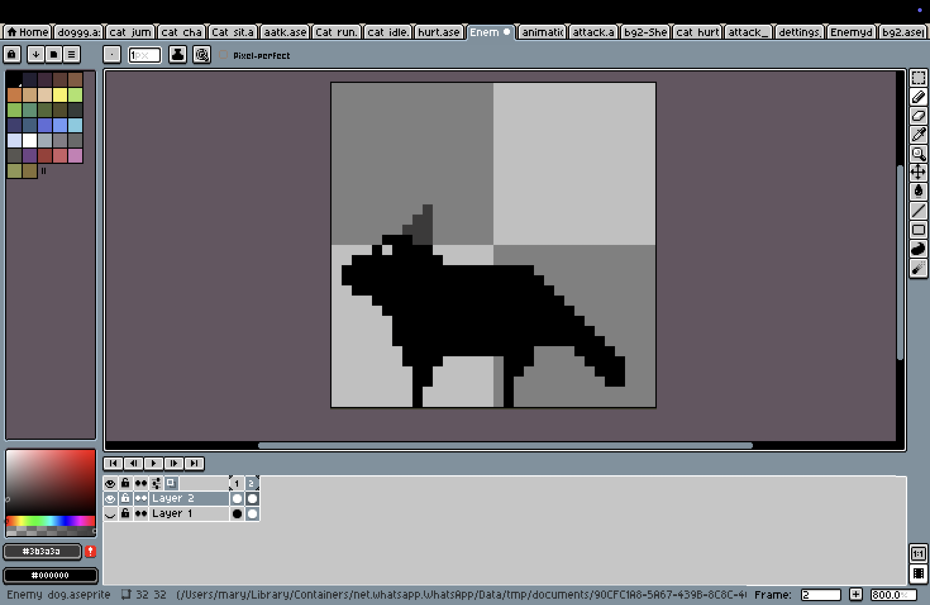

Figure 17: Process of enemy character design

## Footpath

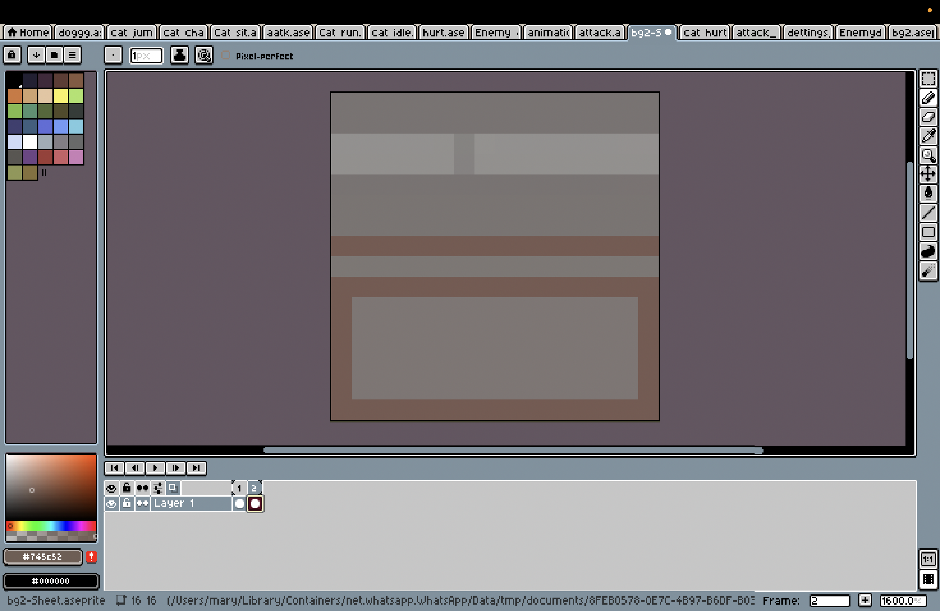

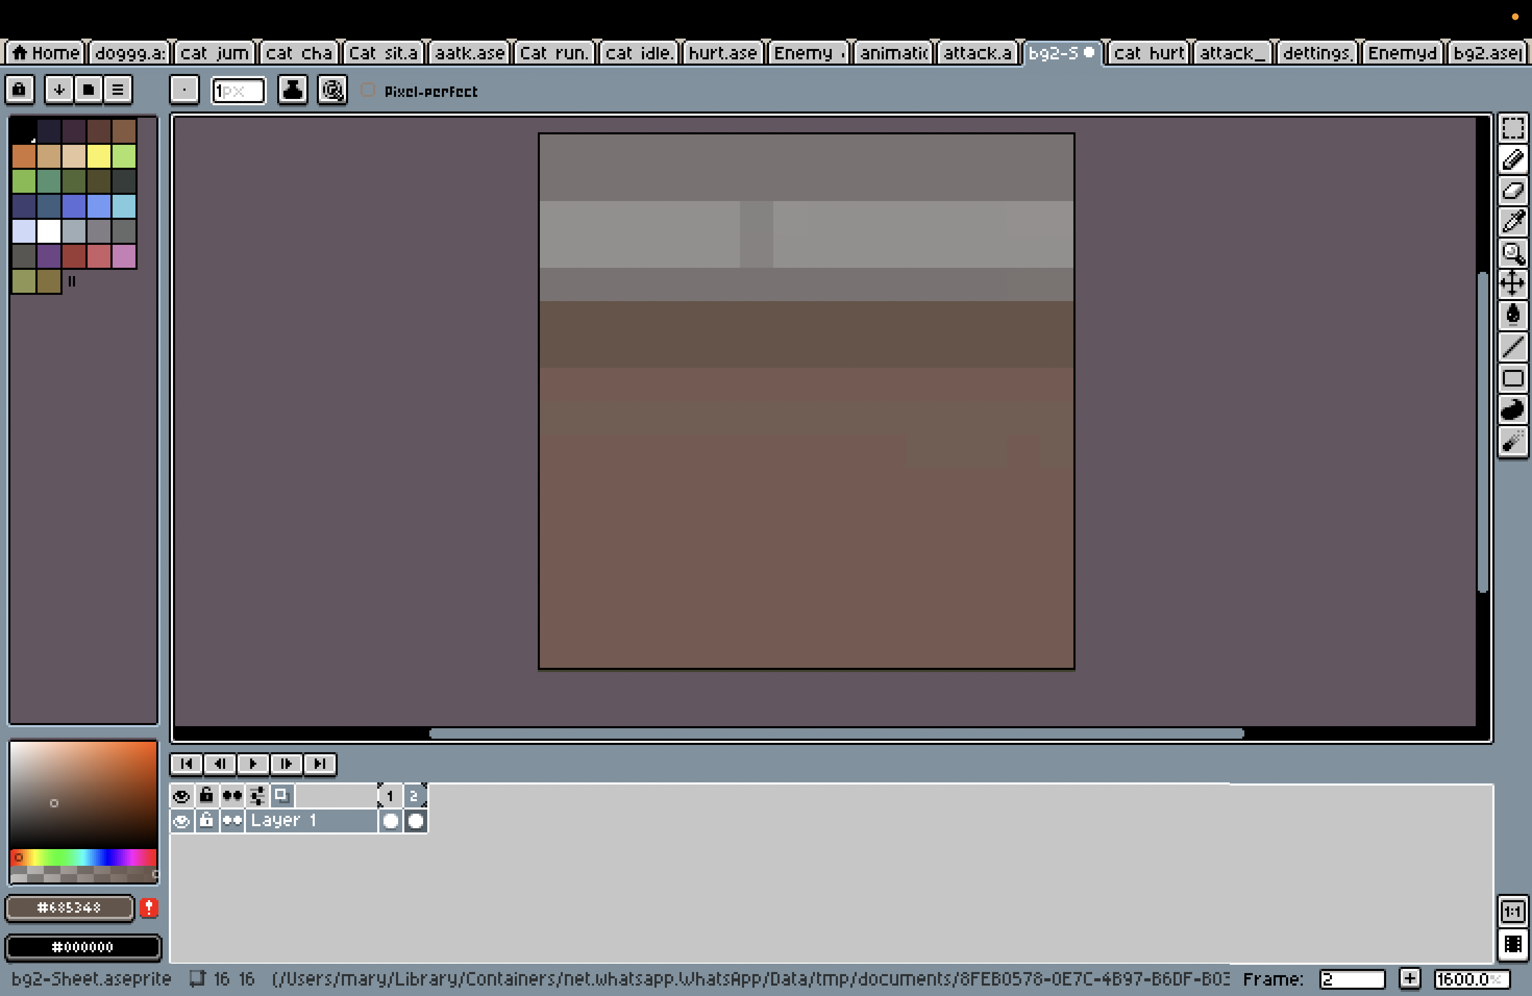

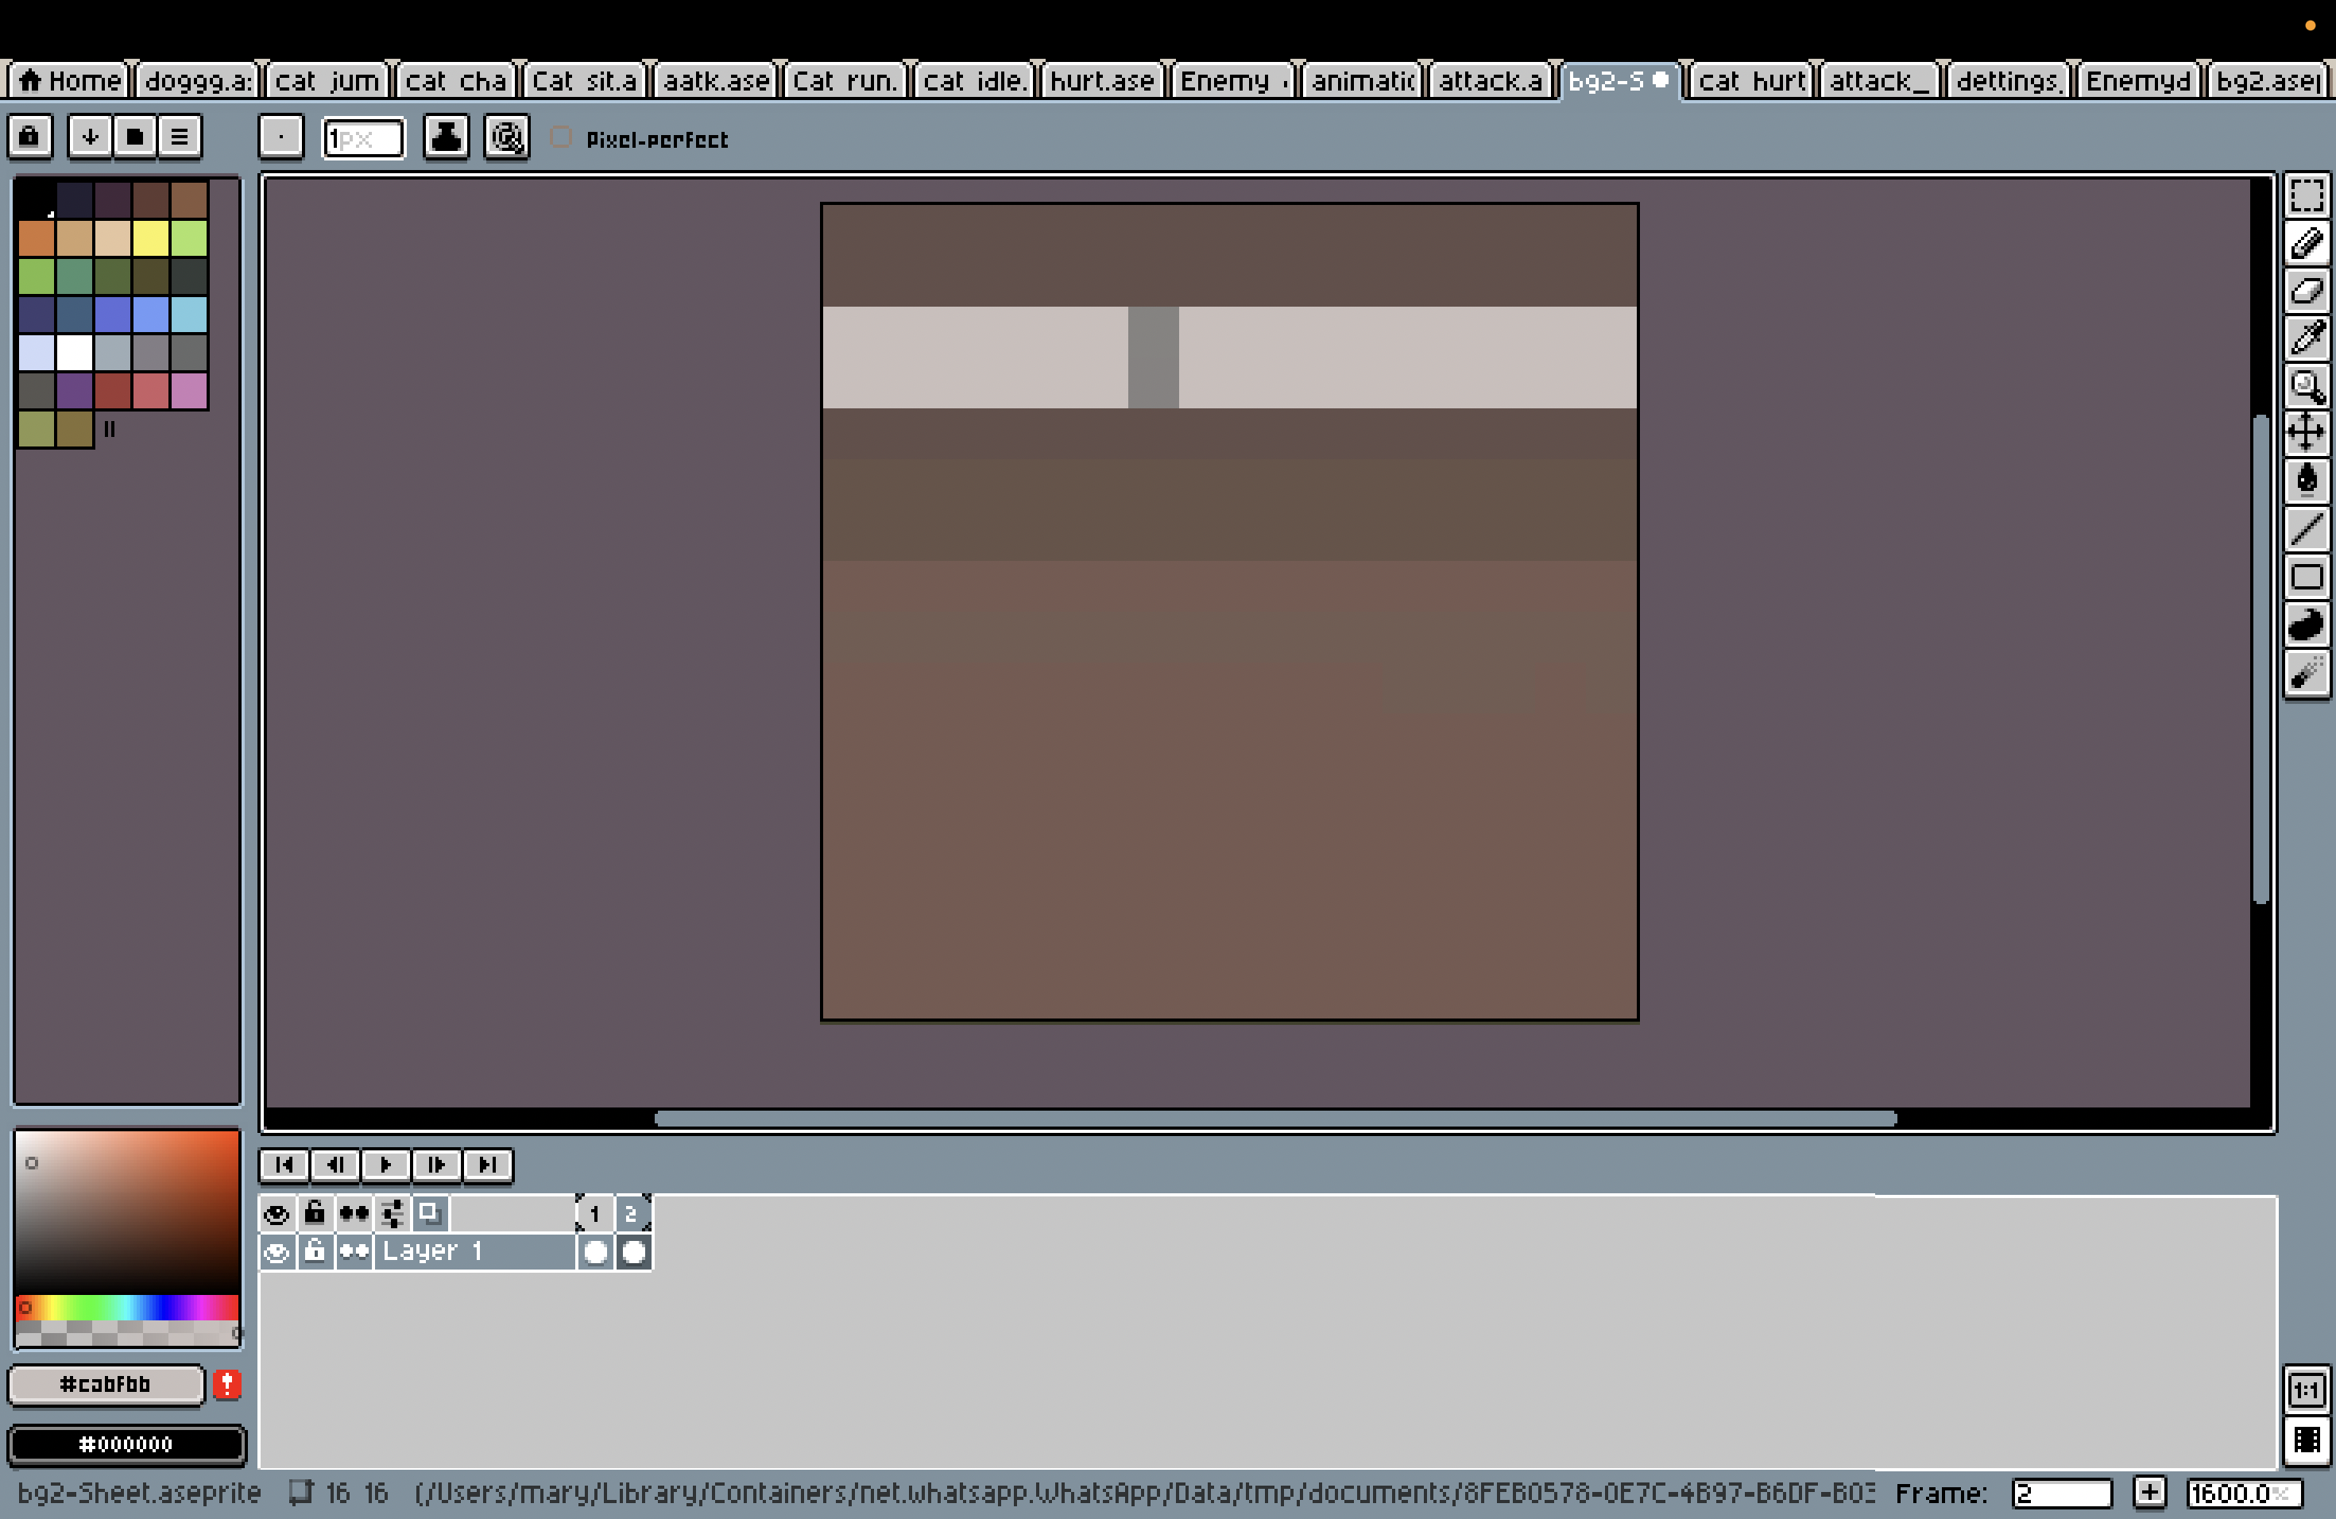

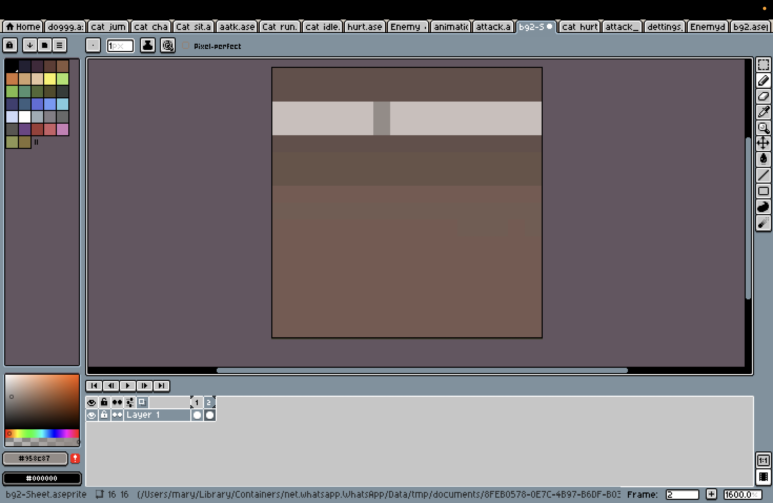

Figure 18: Process of footpath design

## Settings Button

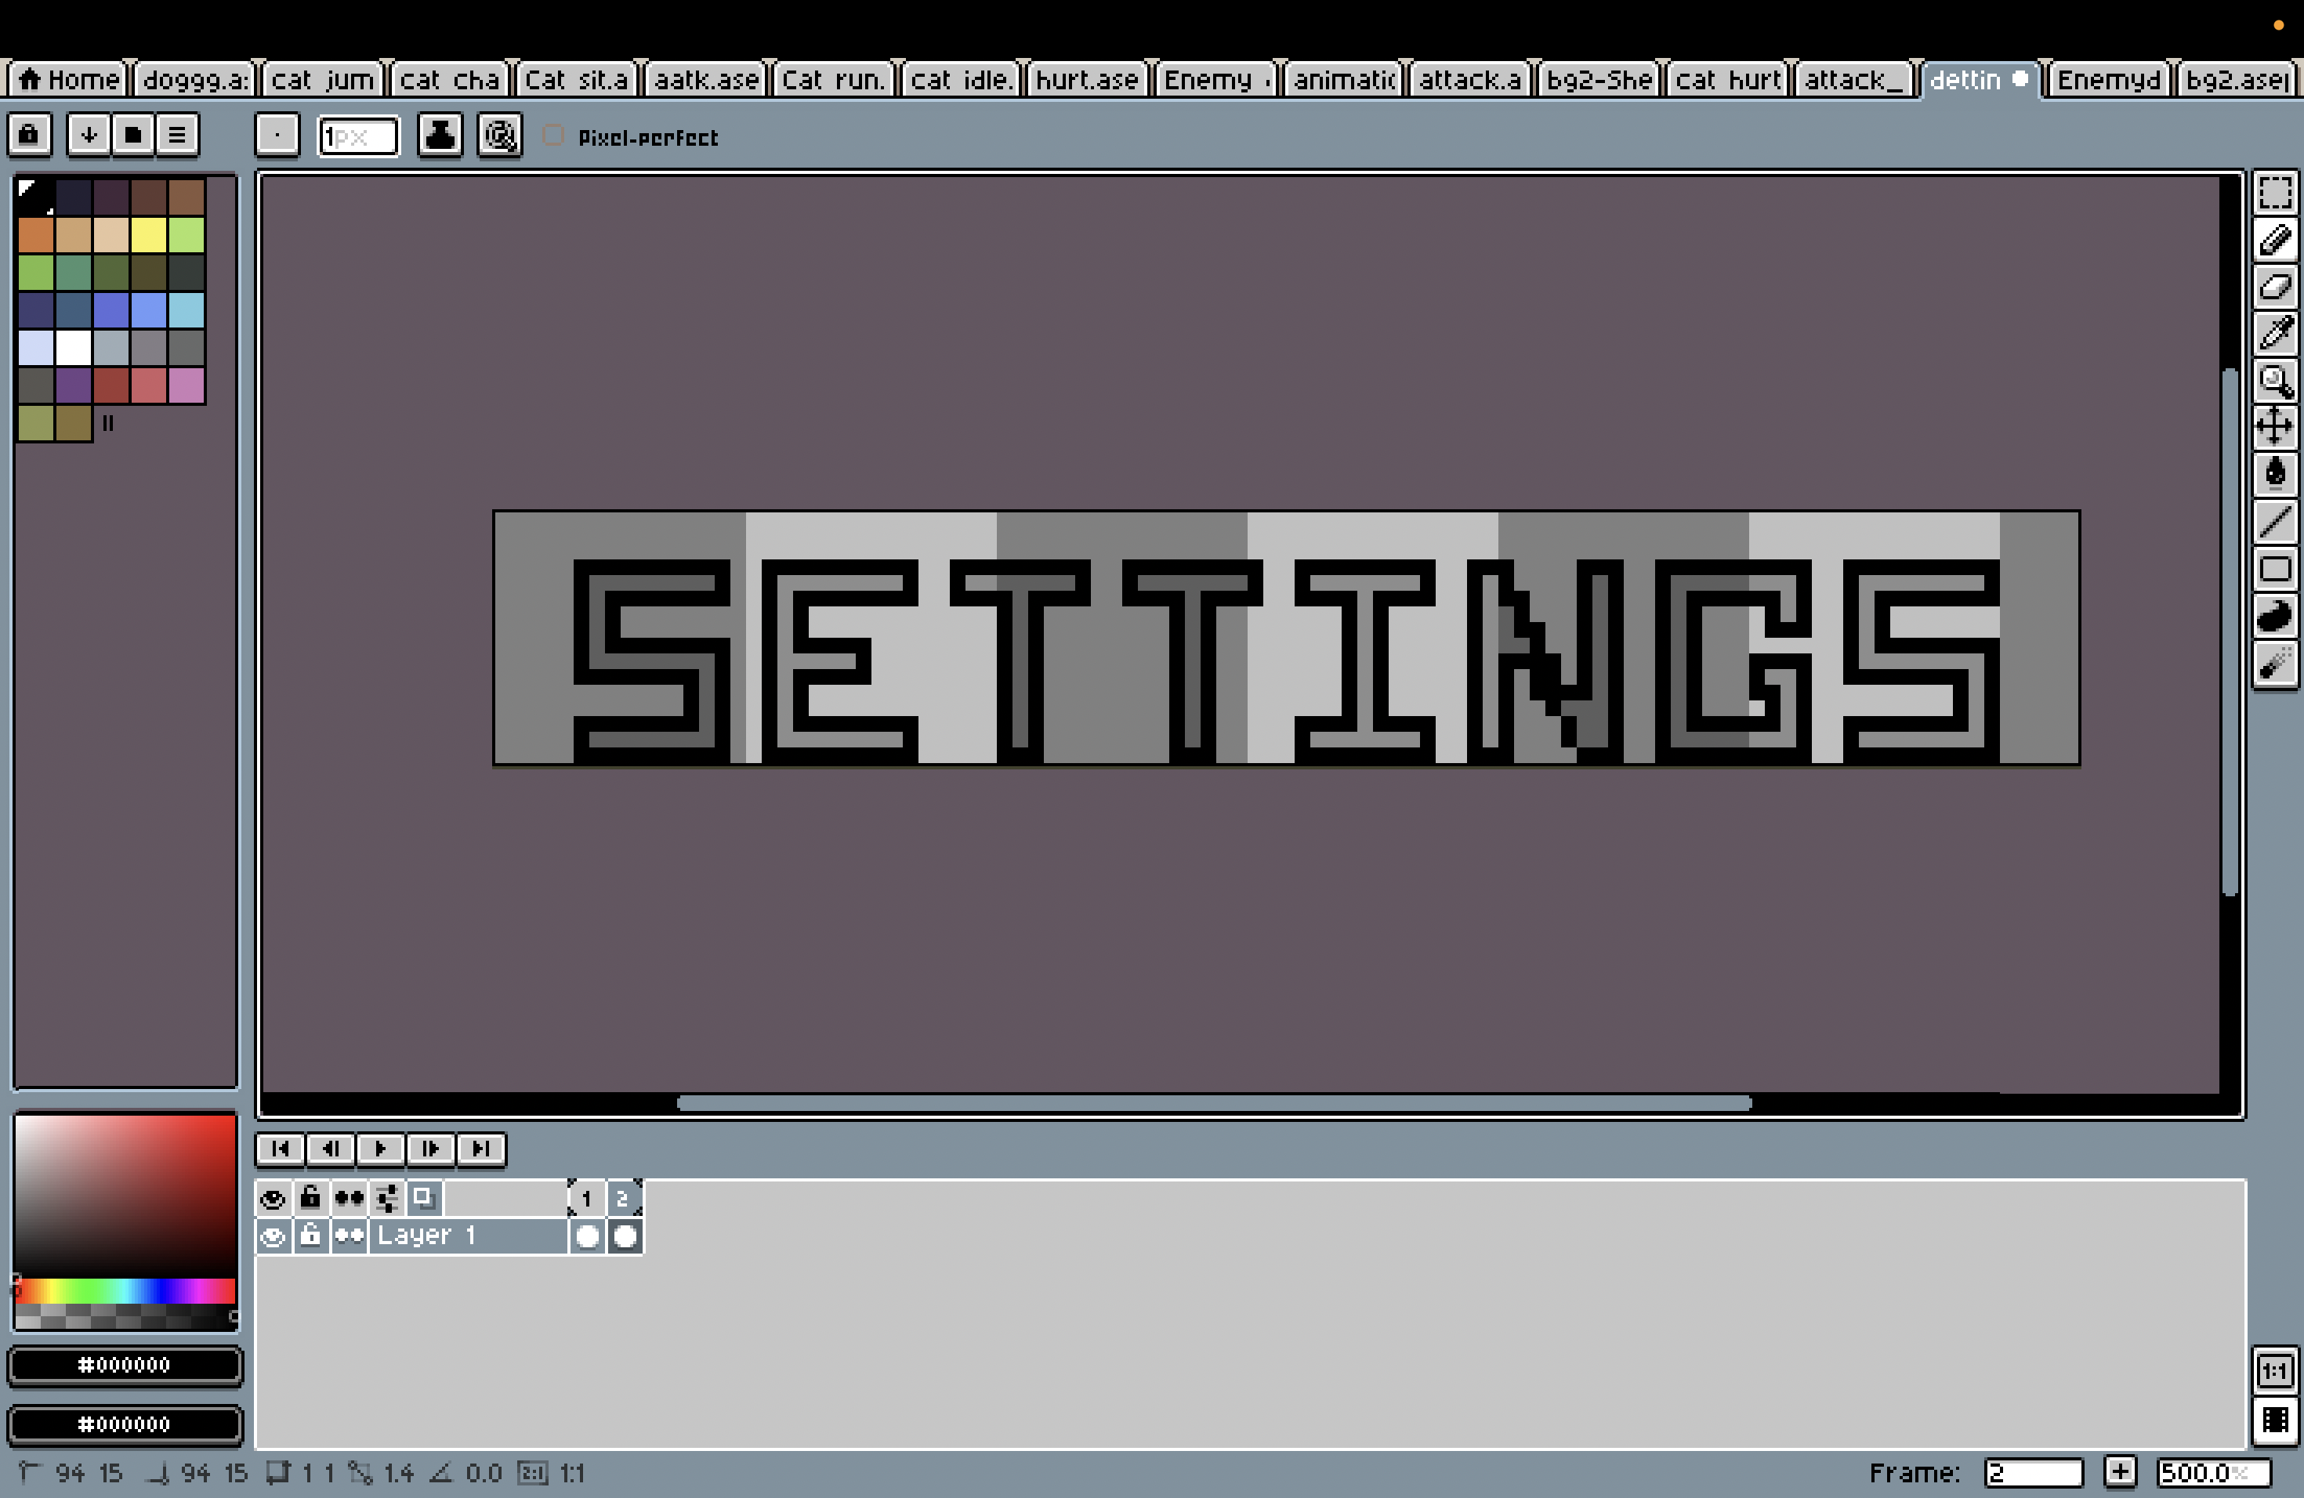

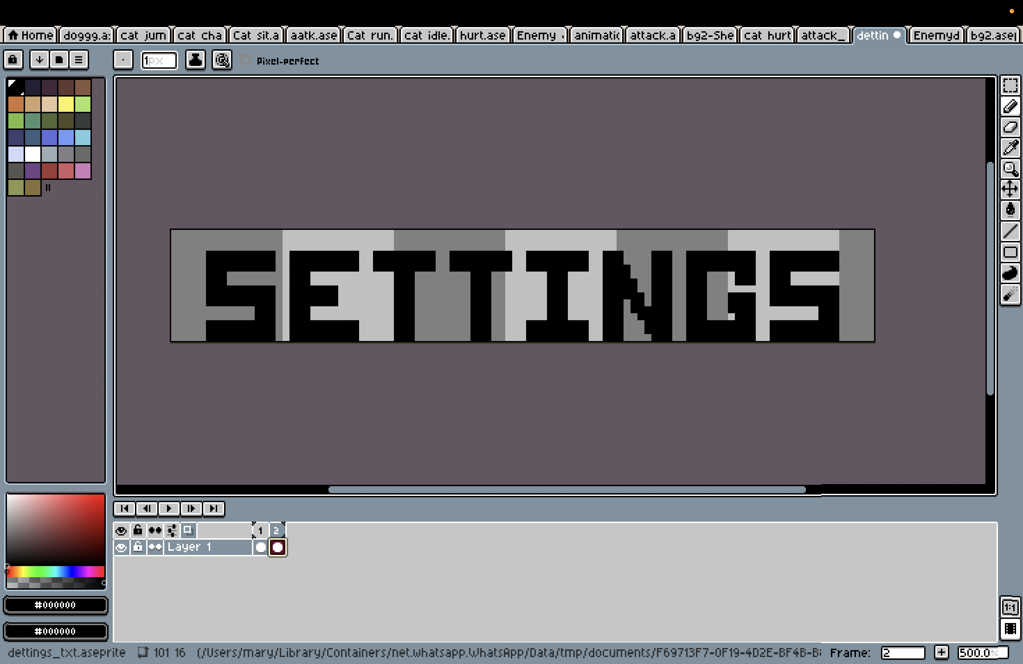

Figure 19: Process of setting button design

## Post-Production

# Resources and testing tools

## Hardware Tools

### XP-Pen Deco Pro

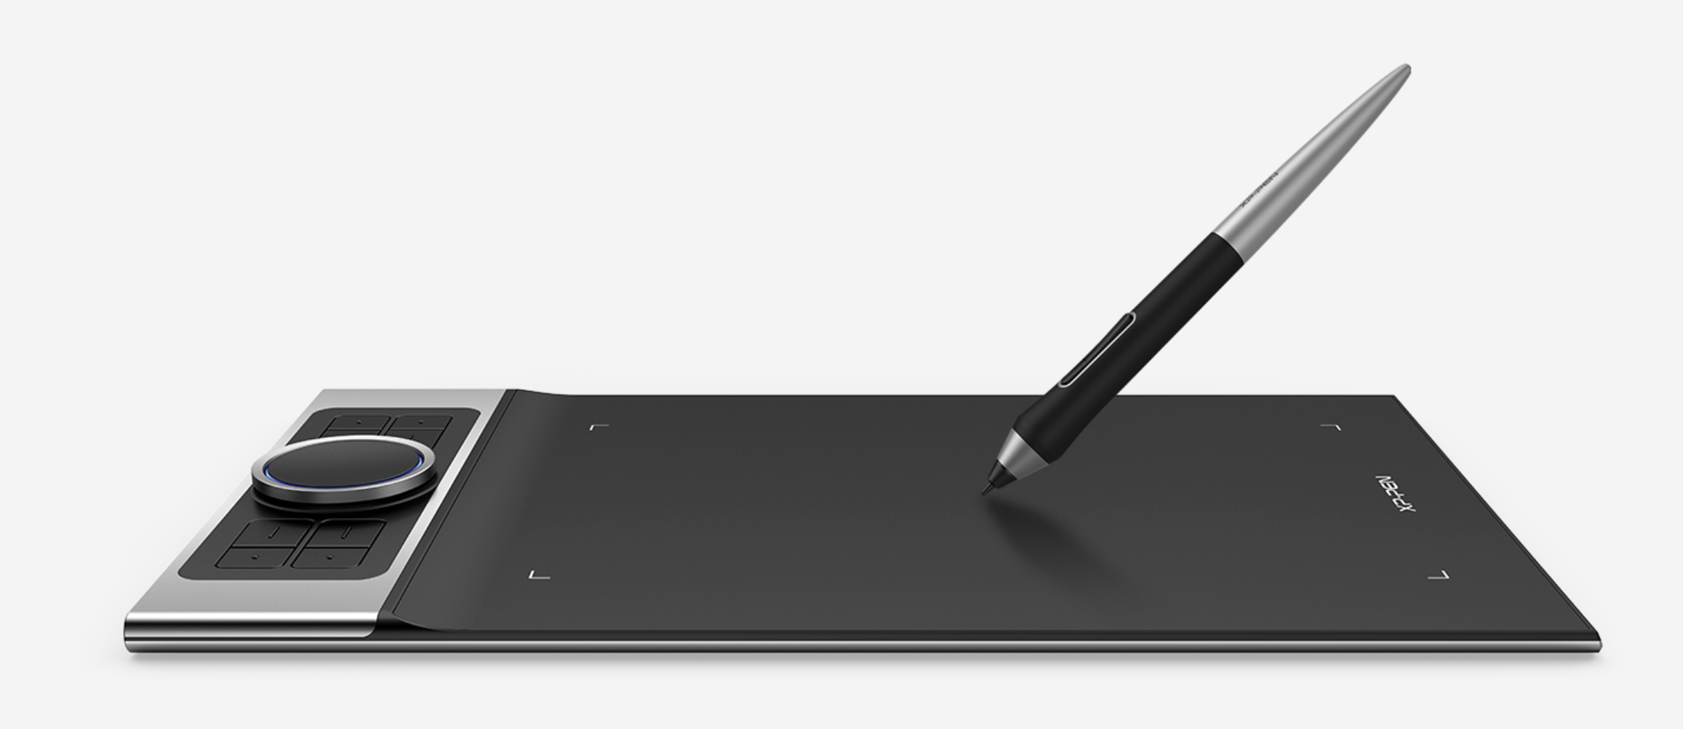

Figure 20: XP-Pen deco pro

* Pressure Sensitivity: 8192 levels
* Resolution: 5080 LPI
* Connectivity: USB-C, Bluetooth (on select models)
* Compatibility: Windows, macOS, Android
* Active Area: 11 x 6 inches

(XP-pen, 2025)

### Lenovo Legion 5

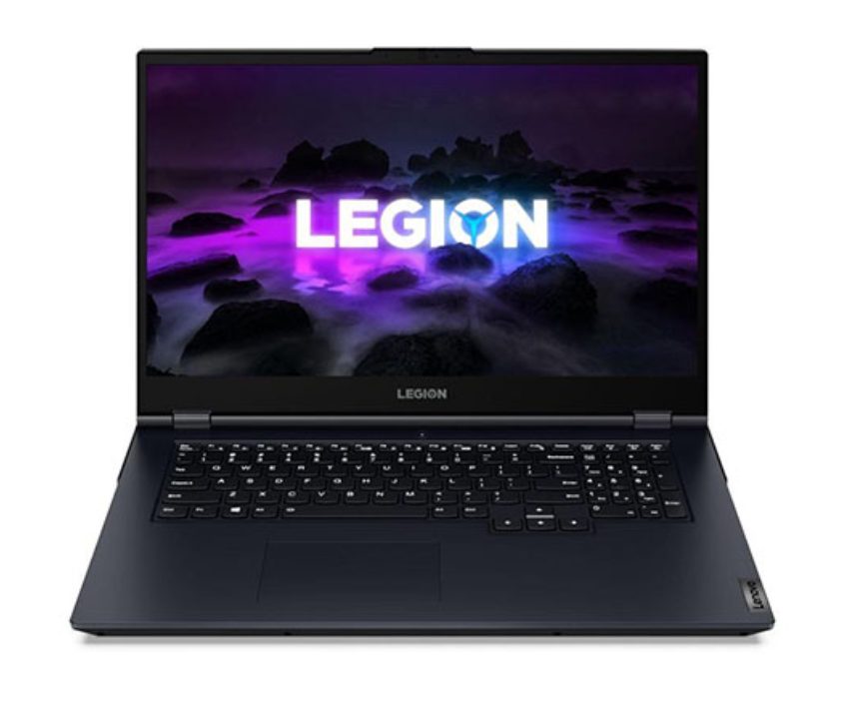

Figure 21: Lenovo Legion 5

* Operating System: Microsoft windows 11
* CPU: 64-bit Intel
* RAM: 512 GB
* Processor: AMD Ryzen 7 7735HS

(gadgetbytenepal, gadgetbytenepal, 2025)

## Software Tools

### G-develop:



Figure 22: G-develop application

GDevelop can provide more possibilities to create games without having to write single code or limit the types of games that can be created (for example 2D, 3D, or multiplayer).

For this project, creating this game primarily used GDevelop. The game logic is implemented, levels looted, user interaction included, and even the game mechanics such as very basic movement, collision detection, and enemies AI have been controlled using GDevelop.

(gdevelop, gdevelop, 2025)

### Aseprite

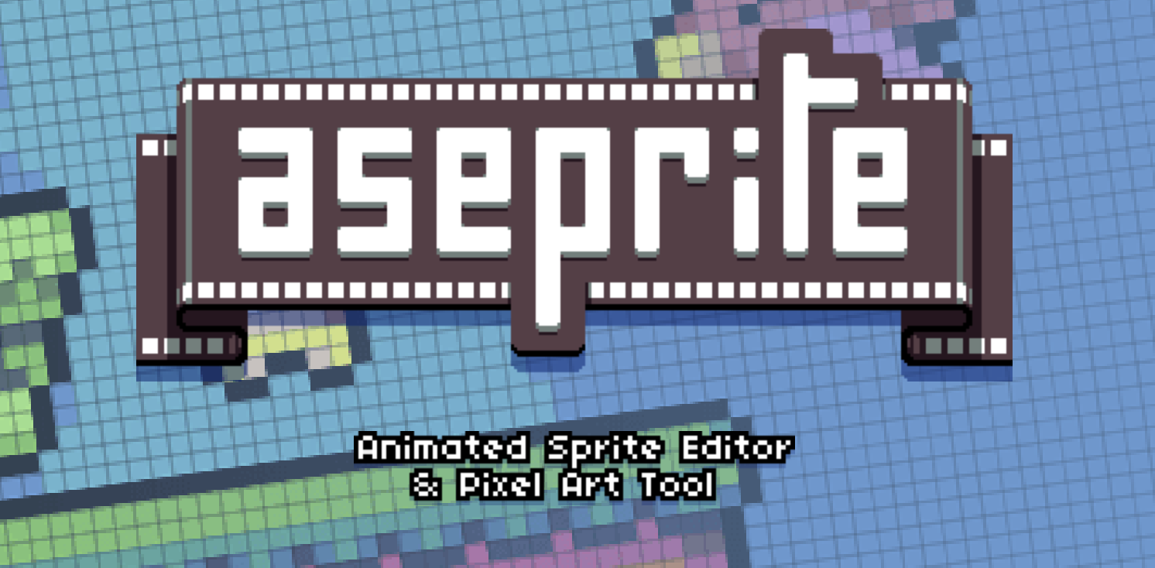

Figure 23: Aseprite

Aseprite is a program that allows you to create 2D animations for video games. Produce sprites, pixel-art, retro-style graphics, and everything one can imagine about the 8-bit and 16-bit era.

For this project, characters have been designed visually, together with the environments and other assets, in the pixel-art style Aseprite. The tool not only contributed much to visual consistency throughout the game but also gave life to the characters and the world through animations and visual storytelling.

(aseprite, 2025)

## Websites used

### Pinterest

* Reference collection

### YouTube

* Game development tutorials

### Google Form

For this project, I used Google Forms to create and send the survey to the intended audience. Google Forms was an easy way to collect responses in real-time and have them organized into Google Sheets. This made collecting data efficient, and I was able to have all the responses that I collected organized, accessible, and analyzable. This made the data reliable and more structured.



Figure 24: Google form

# User Testing & Findings

### Survey

The survey was made up of 20 questions that were developed to gather quantitative and qualitative feedback on aspects of the game; game design, user experience, story, and emotional aspects. When I send the survey to the players, it collected honest feedback from the players which offered me valuable feedback, in all aspects on what the players liked and what they wanted to see improved. This was not only convenient and easy to conduct, but it was one of the most beneficial evaluative testing and audience feedback tools that I used for analysis throughout the development of the game.

Survey Link:

<https://docs.google.com/forms/d/e/1FAIpQLSd87qErgAmPEKQubWMRgG_NcH0lsIGvpCgaLjXojB1w7GWjSw/viewform?usp=dialog>



Figure 25: Survey

### Reflection on the survey result

The survey findings indicate that the game was well received by the target audience. The majority of players indicated that the controls were smooth and easy to learn. The comments indicated the quality of the environment was enjoyable and easy to look at. Respondents resonated with the characters emotionally, and the dialogue coupled with the tone of the story told were appreciated.

Both the visual and sound design decisions were appreciated in the context of the game mood. From a technical standpoint, the game did quite well with only a few minor bugs addressed in the survey. The biggest criticism of the game was related to suggestions for more content and improving the depth of the story.

Overall, the feedback reinforces that the project meet its goals of providing players with an engaging product that was well made.

* 1. Technical Testing

To accomplish testing for technical purposes, the final build for the game was tested first on the Lenovo Legion 5; this was the device used the majority of the time from the start of the development process onward. The game ran well, with no audio or visual interruptions. All pixel visuals were clear and each in-game transition or effects fired at the appropriate pace. Colors in the color palette also appeared bright, and shadows and outlines had an adequate amount of contrast to distinguish them from the primary color.

Further testing was conducted with the XP-Pen Deco Pro, the second device that was used solely in the asset creation phase. This device is primarily a drawing tablet, but I used the screen display device with pen input in order to review pixel precision and quality as it appears when it is played. The artwork was as intended with clean edges and consistent colors suggesting that the visuals were exported as intended from Aseprite into GDevelop.

The sound effects of the game triggered as intended for all interactions and the UI functionality was being prompt. The UI was slightly spaced out in a way when switching between full-screen mode and windowed mode, which was adjusted before finalizing.

All in all, the testing confirmed that the game worked appropriately across all devices used, and there was visual style and interactions the whole way through.

# Conclusion

The report documents the complete development cycle of the digital game project, from pre-production to post-production and key stages during its production. Evidence from various stages, researching material, and references have all been captured, and user testing and feedback documentation to assess how each part of the process contributed to the game development outcomes, also contributed to the overall outcome.

Overall, I can say that I have completed and submitted the digital game project. At the end of the project, this coursework is a representation of the creative journey I have not just undertaken through technical coding in development; it is also a manifestation of planning, design principles, consistency, and engagement which is critical to digital media. It has also taught me a lot about the journey of 2D development of a game and can allow me to have realistic expectations of the industry I am moving into which is growing all the time.

# References

aseprite. (2025). *aseprite*. Retrieved from https://www.aseprite.org/docs/

gadgetbytenepal. (2025). *gadgetbytenepal*. Retrieved from https://www.gadgetbytenepal.com/product/lenovo-legion-5-2021-ryzen-7-5800h-rtx-3050ti/

gadgetbytenepal. (2025). *gadgetbytenepal*. Retrieved from https://www.gadgetbytenepal.com/product/lenovo-legion-5-2021-ryzen-7-5800h-rtx-3050ti/

gdevelop. (2025). *gdevelop*. Retrieved from https://gdevelop.io/

gdevelop. (2025). *gdevelop*. Retrieved from https://gdevelop.io/

GDevelop. (2025). *GDevelop*. Retrieved from https://youtu.be/mckuSpr8vio?si=b6bkhWB83-edXjju

GDevelop. (2025). *GDevelop*. Retrieved from https://youtu.be/HagU5uA0vxM?si=jIBK5EQ4pOVSv2ro

GDevelop. (2025). *GDevelop*. Retrieved from https://youtu.be/0aGBYsrGwm0?si=0Jqdt7qs7vjqTE8G

GDevelop. (2025). *GDevelop*. Retrieved from https://youtu.be/0aGBYsrGwm0?si=0Jqdt7qs7vjqTE8G

GDevelop. (2025). *GDevelop*. Retrieved from https://youtu.be/Li4vhL1bXLc?si=7BG4AryocIIcnemC

GDevelop. (n.d.). *GDevelop*. Retrieved from https://youtu.be/0aGBYsrGwm0?si=0Jqdt7qs7vjqTE8G

XP-pen. (2025). *XP-pen*. Retrieved from https://www.xp-pen.com/product/deco-pro-series-bluetooth.html

# Bibliography

aseprite. (2025). *aseprite*. Retrieved from https://www.aseprite.org/docs/

gadgetbytenepal. (2025). *gadgetbytenepal*. Retrieved from https://www.gadgetbytenepal.com/product/lenovo-legion-5-2021-ryzen-7-5800h-rtx-3050ti/

gadgetbytenepal. (2025). *gadgetbytenepal*. Retrieved from https://www.gadgetbytenepal.com/product/lenovo-legion-5-2021-ryzen-7-5800h-rtx-3050ti/

gdevelop. (2025). *gdevelop*. Retrieved from https://gdevelop.io/

gdevelop. (2025). *gdevelop*. Retrieved from https://gdevelop.io/

GDevelop. (2025). *GDevelop*. Retrieved from https://youtu.be/mckuSpr8vio?si=b6bkhWB83-edXjju

GDevelop. (2025). *GDevelop*. Retrieved from https://youtu.be/HagU5uA0vxM?si=jIBK5EQ4pOVSv2ro

GDevelop. (2025). *GDevelop*. Retrieved from https://youtu.be/0aGBYsrGwm0?si=0Jqdt7qs7vjqTE8G

GDevelop. (2025). *GDevelop*. Retrieved from https://youtu.be/0aGBYsrGwm0?si=0Jqdt7qs7vjqTE8G

GDevelop. (2025). *GDevelop*. Retrieved from https://youtu.be/Li4vhL1bXLc?si=7BG4AryocIIcnemC

GDevelop. (n.d.). *GDevelop*. Retrieved from https://youtu.be/0aGBYsrGwm0?si=0Jqdt7qs7vjqTE8G

XP-pen. (2025). *XP-pen*. Retrieved from https://www.xp-pen.com/product/deco-pro-series-bluetooth.html

# Appendix

## Mail exchange with client

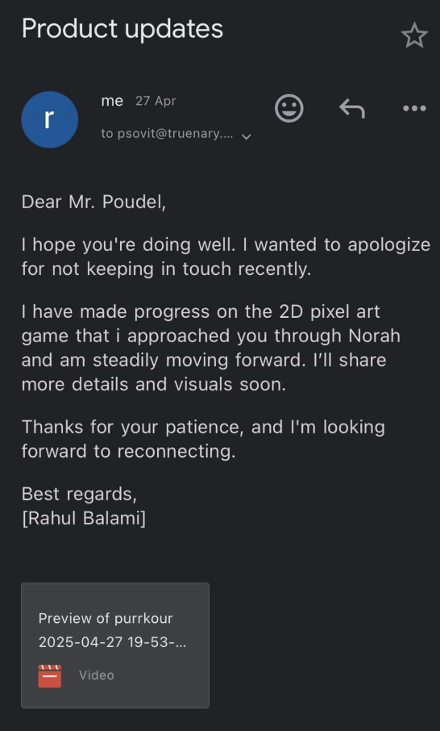

Figure 26: Mail exchange with client

## DMP Letter provided by college

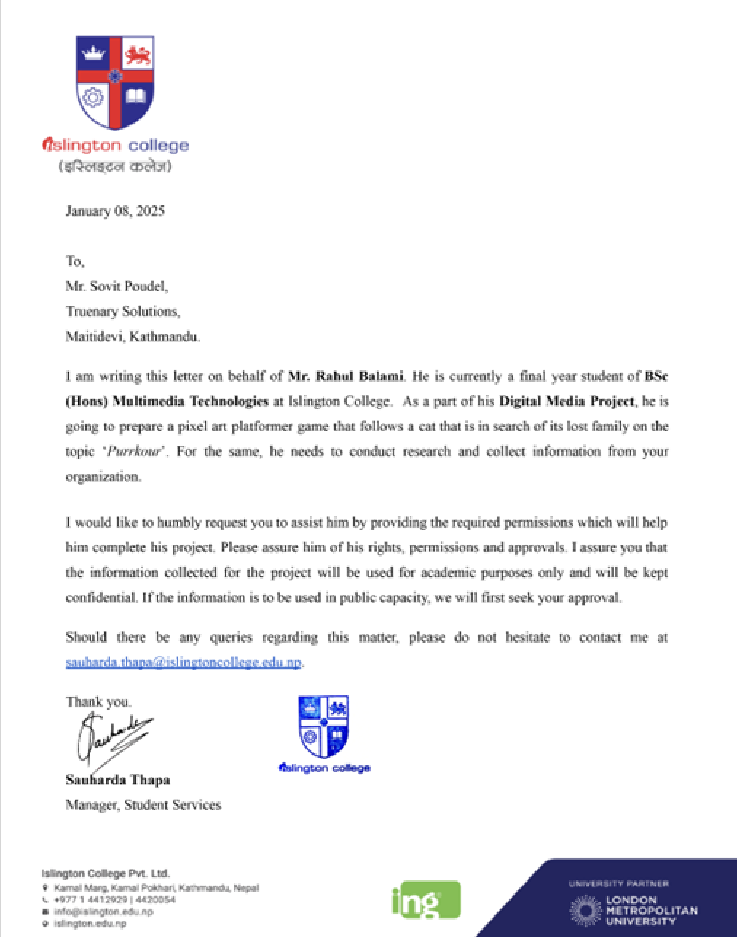

Figure 27: DMP Letter provided by college

## Weekly Logs

